Double Replacement Precipitation Reactions
Name: ______________________ Partner: _________________ Period: ___ Date: ______
Honor Pledge:

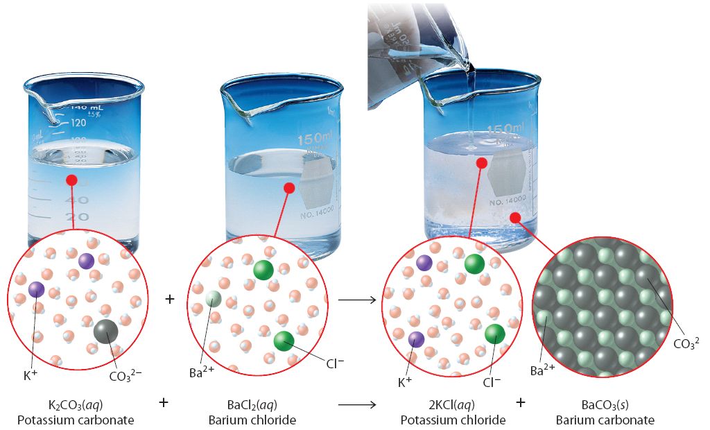
Purpose
The purpose of this lab is to determine which combinations of ions will form water-insoluble precipitates.

Background
Two colorless solutions are poured together. Suddenly a brilliant yellow solid forms and “falls out” of the solution. This solid was once used as a yellow pigment for oil paint. When ionic compounds are dissolved in water, the ions separate and are held apart by the partial charges of the water molecules, (see illustration above). Consequently, whenever you mix solutions containing ions, some ions may stay suspended in water and some may form new combinations of ions. If one or more of these new compounds formed happens to be insoluble in water, it falls out of the solution as a precipitate. Solubility rules guide us in predicting which compounds will become precipitates and which ones will stay suspended as spectator ions.
In this lab you will mix a variety of ionic solutions in certain combinations to see if a precipitate will form. Based on your results, you will infer what reactions have occurred and write complete equations for each reaction that has taken place.

Materials
Safety goggles plastic wash bottle 6 small test tubes test tube holder
BaCl2 K2CrO4 AgNO3 Mg(NO3)2

Pre-Lab
- Predict the products from the following reactions, and using the solubility chart on the last page of this lab, predict if you will have a precipitate or not.
Reactants | Products | Precipitate
Mg(NO3)2 + BaCl2
BaCl2 + K2CrO4

Procedure
- Check your test tubes to make sure all are clean and have no residue. Clean if necessary.
- Using a permanent marker, mark your test tubes 1-6.
- Following the sequence in your data table, mix 15 drops of each solution in the proper test tube. Swirl the test tube gently to fully mix the two solutions.
- Record your observations in the data table below.
- Dispose of all products in your test tubes in your lab sink while running the water. Turn the test tubes up-side down on paper towels to fully drain them.
- Return all chemical solutions to the bin.
- Write the balanced equation for the reaction in the data table.
- Answer all questions.
Data Table

Test Tube | Reactant 1 | Reactant 2 | Results
1 | BaCl2 | Mg(NO3)2
2 | BaCl2 | K2CrO4
3 | K2CrO4 | AgNO3
4 | Mg(NO3)2 | AgNO3
5 | BaCl2 | AgNO3
6 | Mg(NO3)2 | K2CrO4

Balanced Equations
- ___BaCl2 + ___Mg(NO3)2 →
- ___BaCl2 + ___K2CrO4 →
- ___K2CrO4 + ___AgNO3 →
- ___Mg(NO3)2 + ___AgNO3 →
- ___BaCl2 + ___AgNO3 →
- ___Mg(NO3)2 + ___K2CrO4 →

Questions
- What is the function of the spectator ions in the precipitation reactions?
- Explain in your own words why a precipitate forms.
Solubility Rules
These rules should be applied in the order they are listed)
SAP: sodium, ammonium, and potassium compounds are soluble
NAP: nitrates, acetates, and perchlorates are soluble
SLIM: silver, lead, and mercury are insoluble
BIC: bromides, iodides, and chlorides are soluble
CHOPS: carbonates, chromates, hydroxides, oxides, phosphates, and sulfides are insoluble
SCABS: all sulfates are soluble except for calcium, barium, and strontium

