Ecology Unit Vocab: Standard 6 (LAST ONE!!!)
Chapters 13 – 16 in the textbook

Compare and contrast the following terms: (3 pts each)

- Food Chain / Food Web
- Energy pyramid / biomass pyramid/ numbers pyramid
- Abiotic factors / biotic factors
- Habitat / niche
- Predator / prey
- Parasitism / mutualism / commensalism
- Exponential growth / logistical growth
- Density dependent / density independent
- Primary succession / secondary succession
- Transpiration / respiration
- Soil erosion / deposition

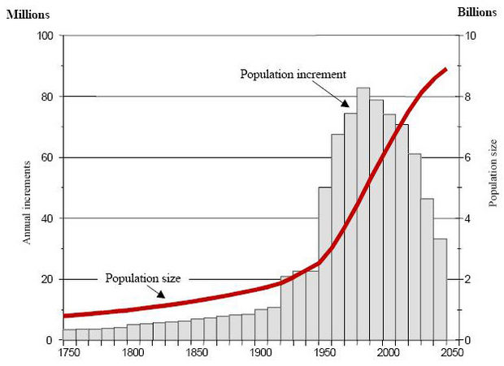
Opinion Constructed Reponses. In order to get full 10 pts, you have to construct a complete paragraph. Have a starter sentence, 3 meat sentences, and a closure sentence.

- What are the “3 R’s”. Do you think this philosophy is really that important?
- Look at the graph to the right. This is referring to the human population. How does this make you feel. Do you think the project could be true? Why or why not? What can we do about it if true?
- Go to the following website. Explore the alternate form of energy that are currently being used all over the world. Which do we use in Rock Hill? Could we use them all in Rock Hill? Why or why not. What one is the safest?

******************************************************************************************************************************
Ecology Unit Vocab: Standard 6 (LAST ONE!!!)
Chapters 13 – 16 in the textbook

Compare and contrast the following terms: (3 pts each)

- Food Chain / Food Web
- Energy pyramid / biomass pyramid/ numbers pyramid
- Abiotic factors / biotic factors
- Habitat / niche
- Predator / prey
- Parasitism / mutualism / commensalism
- Exponential growth / logistical growth
- Density dependent / density independent
- Primary succession / secondary succession
- Transpiration / respiration
- Soil erosion / deposition

Opinion Constructed Reponses. In order to get full 10 pts, you have to construct a complete paragraph. Have a starter sentence, 3 meat sentences, and a closure sentence.

- What are the “3 R’s”. Do you think this philosophy is really that important?
- Look at the graph to the right. This is referring to the human population. How does this make you feel. Do you think the project could be true? Why or why not? What can we do about it if true?
- Go to the following website. Explore the alternate form of energy that are currently being used all over the world. Which do we use in Rock Hill? Could we use them all in Rock Hill? Why or why not. What one is the safest?

