How Stem Cells Work
by Stephanie Watson and Craig Freudenrich, Ph.D.
http://science.howstuffworks.com
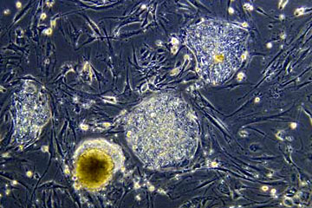

Microscopic view of a colony of undifferentiated human embryonic stem cells being studied in developmental biologist James Thomson's research lab at the University of Wisconsin-Madison.
Photo courtesy University of Wisconsin-Madison

Introduction to How Stem Cells Work
Many diseases kill cells within organs, claiming lives or impairing a person's ability to live a normal life. For example, about 5.8 million Americans have heart failure and 670,000 people are diagnosed with it each year [source: Centers for Disease Control]. In heart failure, much of the heart muscle itself dies, so the heart cannot sufficiently pump blood. Similarly, about 23.6 million Americans have diabetes [source: NIDDK, NIH]. Five to 10 percent of these people have Type I diabetes in which the insulin-producing cells of the pancreas are dead. Finally, about 1 million Americans live with Parkinson's disease [source: Parkinson's Disease Foundation]. In this disease, cells that make the neurotransmitter dopamine, which helps control movement, die. Patients with Parkinson's disease have tremors and uncontrollable movements. But what if these dead cells could be replaced with fresh cells? Could the patients be treated and live normal lives? That's the goal of stem cell research.
In this article, we'll look at stem cells, starting with the accompanying picture above. In the photo, the embryonic stem cell colonies are the rounded, dense masses of cells. The flat elongated cells are fibroblasts used as "feeder cells." We'll also find out how stem cells work, discover their potential to treat disease and get inside the ongoing debate surrounding their research and use. But first, let's cover some basics.
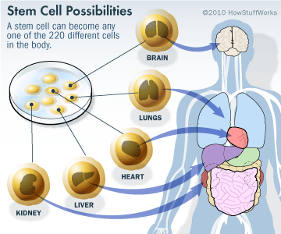
A stem cell is essentially the building block of the human body. Stem cells are capable of dividing for long periods of time, are unspecialized, but can develop into specialized cells. The earliest stem cells in the human body are those found in the human embryo. The stem cells inside an embryo will eventually give rise to every cell, tissue and organ in the fetus's body. Unlike a regular cell, which can only replicate to create more of its own kind of cell, a stem cell is pluripotent. When it divides, it can make any one of the 220 different cells in the human body. Stem cells also have the capability to self-renew -- they can reproduce themselves many times over.
There are several types of stem cells, including:
- Embryonic stem cells - Embryonic stem cells include those found within the embryo, the fetus or the umbilical cord blood. Depending upon when they are harvested, embryonic stem cells can give rise to just about any cell in the human body.
- Adult stem cells - Adult stem cells can be found in infants, children and adults. They reside in already developed tissues such as those of the heart, brain and kidney. They usually give rise to cells within their resident organs.
- Induced pluripotent stem cells (IPSC)- These stem cells are adult, differentiated cells that have been experimentally "reprogrammed" into a stem cell-like state.

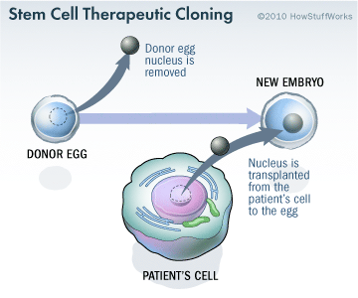
So how do all these types of stem cells work? And what are their potential uses? Let's find out -- starting with embryonic stem cells.

Embryonic Stem Cells
Once an egg cell is fertilized by a sperm, it will divide and become an embryo. In the embryo, there are stem cells that are capable of becoming all of the various cell types of the human body. For research, scientists get embryos in two ways. Many couples conceive by the process of in vitro fertilization. In this process, a couple's sperm and eggs are fertilized in a culture dish. The eggs develop into embryos, which are then implanted in the female. However, more embryos are made than can be implanted. So, these embryos are usually frozen. Many couples donate their unused embryos for stem cell research.
The second way in which scientists get embryos is therapeutic cloning. This technique merges a cell (from the patient who needs the stem cell therapy) with a donor egg. The nucleus is removed from the egg and replaced with the nucleus of the patient's cell. (For a detailed look at the process, see How Cloning Works) This egg is stimulated to divide either chemically or with electricity, and the resulting embryo carries the patient's genetic material, which significantly reduces the risk that his or her body will reject the stem cells once they are implanted.
Both methods -- using existing fertilized embryos and creating new embryos specifically for research purposes -- are controversial. But before we get into the controversy, let's find out how scientists get stem cells to replicate in a laboratory setting in order to study them. When an embryo contains about eight cells, the stem cells are totipotent - they can develop into all cell types. At three to five days, the embryo develops into a ball of cells called a blastocyst. A blastocyst contains about 100 cells total and the stem cells are inside. At this stage, the stem cells are pluripotent - they can develop into almost any cell type.
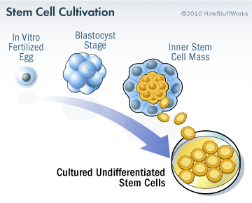
To grow the stem cells, scientists remove them from the blastocyst and culture them (grow them in a nutrient-rich solution) in a Petri dish in the laboratory. The stem cells divide several times and scientists divide the population into other dishes. After several months, there are millions of stem cells. If the cells continue to grow without differentiating, then the scientists have a stem cell line. Cell lines can be frozen and shared between laboratories. As we will see later, stem cell lines are necessary for developing therapies. Today, many expectant mothers are asked about umbilical cord banking -- the process of storing umbilical cord blood after giving birth. Why would someone want to do that? Once a mother gives birth, the umbilical cord and remaining blood are often discarded. However, this blood also contains stem cells from the fetus. Umbilical cord blood can be harvested and the embryonic stem cells grown in culture. Unlike embryonic stem cells from earlier in development, fetal stem cells from umbilical cord blood are multipotent - they can develop into a limited number of cell types.
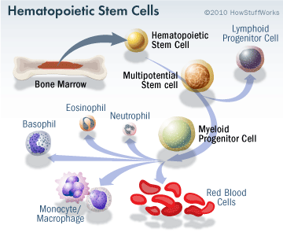
Now that you have a better understanding of embryonic stem cells, let's look at adult stem cells.
Adult Stem Cells
You can think of adult stem cells as our built-in repair kits, regenerating cells damaged by disease, injury and everyday wear and tear. These undifferentiated cells reside among other differentiated cells in a tissue or organ; they divide and become specialized to repair or replace the surrounding differentiated cells. A common example of adult stem cells is hemopoietic stem cells, which are found in red bone marrow. These stem cells differentiate into various blood cells (red blood cells, lymphocytes, platelets-- see How Blood Works for more information). For example, red blood cells are not capable of reproducing and survive for about 28 days. To replace worn-out red blood cells, hemopoietic stem cells in the bone marrow divide and differentiate into new red blood cells.
Bone marrow also contains a second type of adult stem cell known as a stromal or mesenchymal stem cell. Stromal stem cells become bone, cartilage, fat and connective tissues found in bone. Adult stem cells have also been found in many other tissues such as the brain, skeletal muscle, blood vessels, skin, liver, teeth and the heart. Regardless of the source, adult stem cells are multipotent - they can develop into a limited number of cell types. Although adult stem cells exist in many tissues, their numbers are small, perhaps one adult stem cell for every 100,000 surrounding cells. These stem cells look like the surrounding cells, so it's difficult to tell them apart. But researchers have developed an interesting way to identify them by "lighting them up." All cells have unique proteins on their surface called receptors. Receptors bind chemical messages from other cells as part of cell-to-cell communication. Researchers use these receptors -- or markers -- to identify and isolate adult stem cells by "tagging" the chemical messages that bind to those specific receptors on the stem cell with fluorescent molecules. Once the fluorescent chemical message binds to the receptor on the surface of the stem cell, the stem cell will "light up" under fluorescent light. The "lighted" stem cell can then be identified and isolated. Like embryonic stem cells, adult stem cells can be grown in culture to establish stem cell lines. Adult stem cells were once believed to be more limited than embryonic stem cells, only giving rise to the same type of tissue from which they originated. But new research suggests that adult stem cells may have the potential to generate other types of cells, as well. For example, liver cells may be coaxed to produce insulin, which is normally made by the pancreas. This capability is known as plasticity or transdifferentiation
It used to be believed that there were only two types of stem cells -- embryonic and adult -- but there's another kid on the stem cell block. Keep reading to learn about this "new" type: the induced pluripotent stem cell.
SAVE THOSE TEETH
Dentists usually discard wisdom teeth after they've been extracted -- but maybe they should start saving them; they just might be useful in make stem cells. Recently, a group of Japanese scientists made induced pluripotent stem cells (IPSCs) from the tooth pulp of extracted wisdom teeth. They used viruses to deliver stem cell factors to mesenchymal stromal cells isolated from the pulp of third molars. The resulting IPSCs were similar to embryonic stem cells.
In 2003, an NIH researcher, Sangtao Shi, extracted stem cells from his daughter's baby teeth. The stem cells grew in culture and could form bone when implanted into mice. Potentially, you could bank stem cells from your teeth for future use, but it would be an expensive process.
Maybe that's what the tooth fairy does with all those teeth?
Induced Pluripotent Stem Cells (IPSCs)
Whether from embryos or adult tissues, stem cells are few. But many are needed for cell therapies. There have been ethical and political problems with using embryonic stem cells -- so if there were a way to get more stem cells from adults, it might be less controversial. Enter the IPSC.
Every cell in the body has the same genetic instructions. So what makes a heart cell different from a liver cell? The two cells express different sets of genes. Likewise, a stem cell turns on specific sets of genes to differentiate into another cell. So, is it possible to reprogram a differentiated cell so that it reverts back to a stem cell? In 2006, scientists did just that. They used a virus to deliver four stem cell factors into skin cells. The factors caused the differentiated stem cells to go into an embryonic-stem-cell-like state. The resulting cells, called induced pluripotent stem cells (IPSCs), shared many characteristics with human embryonic stem cells. The structures of IPSCs were similar, they expressed the same markers and genes, and they grew the same. And the researchers were able to grow the IPSCs into cell lines.
There are many more differentiated cells in the human body than stem cells, embryonic or adult. So, vast amounts of stem cells could be made from a patient's own differentiated cells, like skin cells. Making IPSCs does not involve embryos, so this would circumvent the ethical and political issues involved in stem cell research. However, making ISPSCs is a recent development, so scientists need to do more research before they can be used for therapies. First, we need to understand the "reprogramming" process better. And then we need to investigate whether IPSCs are just similar enough or are actually identical to embryonic stem cells. Current research is focused on these questions, but reprogramming cells to make IPSCs has great potential.
Now that you have a good idea of what stems cells are and how they work, let's see how they can be used to treat diseases.
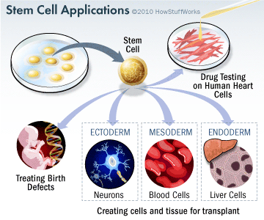
Using Stem Cells to Treat Disease
The first step in using stem cells for disease treatment is to establish stem cell lines, which researchers have accomplished. Next, scientists must be able to turn on specific genes within the stem cells so that the stem cells will differentiate into any cell they wish. But scientists have not learned how to do this yet; so, studying stem cell differentiation is an active area of research. Once scientists can create differentiated cells from stem cells, then there are many possibilities for their use, such as drug testing and cell-based therapies. For example, let's say you want to test new drugs to treat heart diseases. Currently, new drugs must be tested on animals. The data from animal research must be interpreted and then extrapolated to humans prior to human clinical trials. But suppose you could test them directly on human heart cells. To do this, human stem cell lines could be treated to differentiate into human heart cells in a dish. The potential drugs could be tested on those cells and the data would be directly applicable to humans. This use could save vast amounts of time and money in bringing new drugs to market.
Stem-cell-based therapies are not new. The first stem-cell-based therapy was a bone marrow transplant used to treat leukemia. In this procedure, the patient's existing bone marrow is destroyed by radiation and/or chemotherapy. Donor bone marrow is injected into the patient and the bone marrow stem cells establish themselves in the patient's bones. The donor bone marrow cells differentiate into blood cells that the patient needs. Often, the patient must take drugs to prevent his or her immune system from rejecting the new bone marrow. But this procedure uses existing hemopoietic stem cells. How would you use stem cell lines? Let's look at how stem cells might be used to treat heart failure.
Ideally, to treat a failing heart, scientists could stimulate stem cells to differentiate into heart cells and inject them into the patient's damaged heart. There, the new heart cells could grow and repair the damaged tissue. Although scientists cannot yet direct stem cells to differentiate into heart cells, they have tested this idea in mice. They have injected stem cells (adult, embryonic) into mice with damaged hearts. The cells grew in the damaged heart cells and the mice showed improved heart function and blood flow.
In these experiments, exactly how the stem cells improved heart function remains controversial. They may have directly regenerated new muscle cells. Alternatively, they may have stimulated the formation of new blood vessels into the damaged areas. And the new blood flow may have stimulated existing heart stem cells to differentiate into new heart muscle cells. These experiments are currently being evaluated.
One major obstacle in stem cell use is the problem of rejection. If a patient is injected with stem cells taken from a donated embryo, his or her immune system may see the cells as foreign invaders and launch an attack against them. Using adult stem cells or IPSCs could overcome this problem somewhat, since stem cells taken from the patient would not be rejected by his or her immune system. But adult stem cells are less flexible than embryonic stem cells and are harder to manipulate in the lab. And IPSC technology is too new for transplantation work.
Finally, by studying how stem cells differentiate into specialized cells, the information gained can be used to understand how birth defects occur and possibly, how to treat them.
So, if there's so much potential in stem cell research, why all the controversy? Let's investigate the current ethical and political issues.
STEM CELL RESEARCH ADVOCATES
Since 1991, when he was diagnosed with Parkinson's disease (a degenerative brain disorder that affects movement), actor Michael J. Fox has been a vocal proponent for stem cell research. His foundation has donated more than $205 million to help fund Parkinson's research [source: Michael J. Fox Foundation]. Fox and his foundation are hoping that scientists will one day be able to coax stem cells into producing dopamine, a chemical in the body that is deficient in patients with Parkinson's disease.
Former first lady Nancy Reagan also became an advocate for stem cell research when her husband, former President Ronald Reagan, was stricken with Alzheimer's, another degenerative brain disease. He died of Alzheimer's in the summer of 2004.
Stem Cell Research Controversy
Stem cell research has become one of the biggest issues dividing the scientific and religious communities around the world. At the core of the issue is one central question: When does life begin? At this time, to get stem cells that are reliable, scientists either have to use an embryo that has already been conceived or else clone an embryo using a cell from a patient's body and a donated egg. Either way, to harvest an embryo's stem cells, scientists must destroy it. Although that embryo may only contain four or five cells, some religious leaders say that destroying it is the equivalent of taking a human life. Inevitably, this issue entered the political arena.
In 1996, Congress passed a rider to the federal appropriations bill called the Dickey-Wicker amendment. Representatives Jay Dickey and Roger Wicker proposed banning the use of federal monies for any research in which a human embryo is created or destroyed. Federal monies are a primary source of funding for stem cell research. The amendment has been renewed every year since that time.
In 2001, President George W. Bush further restricted federal stem cell research. In an executive order, Bush stated that federal funds could only be used for research on human embryonic stem cell lines that had already been established (only 22 cell lines). This prevented researchers from creating more embryonic stem cell lines for research.
In 2009, President Barack Obama issued an executive order to expand embryonic stem cell research. Obama's administration allowed federal funding of embryonic stem cell research if the following conditions applied:
- The cell line was one of the 22 in existence during the Bush administration or was created from embryos that had been discarded after in vitro fertilization procedures.
- The donors of the embryos were not paid in any way.
- The donors clearly knew that the embryos would be used for research purposes prior to giving consent.
According to the administration, the new policy did not violate the Dickey-Wicker amendment because the money did not finance the creation of new embryos (they had already been created by private means) and did not finance the destruction of them.
In 2009, two researchers from Boston, Dr. James Sherley of the Boston Biomedical Research Institute and Dr. Theresa Deisher of the Ava Maria Biotechnology Company, and other agencies filed a lawsuit against the government. Initially, the lawsuit was dismissed because the judge ruled that the plaintiffs had no legal standing (i.e. they were not affected materially by the new rules). However, a court of appeals overturned the initial ruling. The two scientists remained plaintiffs. The scientists claimed that, because they used adult stem cells exclusively in their research, the new rules would increase competition for federal research dollars, thereby affecting their ability to obtain funding. Federal Judge Royce Lamberth upheld the appeals court ruling. He placed an injunction preventing the new rules from going into place. He claimed that the rules violated the Dickey-Wicker amendment because embryos must be destroyed in the process of creating embryonic stem cell lines.
In September 2010, The New York Times reported that the U.S. Court of Appeals ruled that federal funding of embryonic stem cell research could continue under the new rules while the court considers Judge Lamberth's ruling [source: New York Times]. This ruling allows researchers to continue feeding embryonic stem cell cultures, experimenting with mice, and other research activities until this court rules, the U.S. Supreme Court weighs in, or Congress passes legislation that clarifies the issues. In the meantime, stem cell research and the careers of stem cell researchers hang on a legal roller coaster. Although stem cells have great potential for treating diseases, much work on the science, ethical and legal fronts remains.

