Midterm Review

Unit 1: Introduction
- A testable possible explanation of an observation is a ___________________.
- A scientific __________ may be revised as new evidence is presented.
- All organisms are composed of _____________.
- All living things maintain a balance within their cells and the environments through the process of ______________.
- Honeydough Yeast Company is debating using a new sugar form to see if the yeast reproduction can be sped up. In order to do this, they are testing 3 new sugar forms, sucrose, lactose, and galactose. Right now, Honeydough Yeast Co. uses glucose. They will be using the same temperature, same amount of sugar, and same amount of water. In this experiment, what is the following:
  - Hypothesis:
  - Independent Variable:
  - Dependent Variable:
  - Constants:
  - Control:
- Review the steps of Tech Design vs. Science Investigation.
- Cells __________ organs __________

Unit 2: Cells
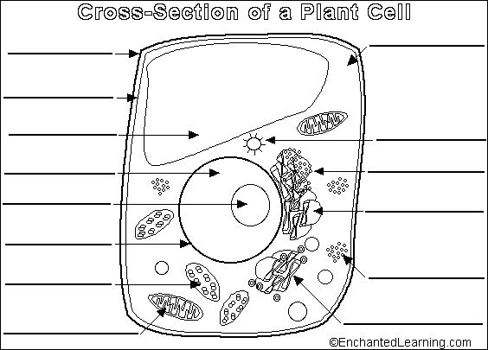
- What is the main difference between prokaryotes and eukaryotes? _____________________________
- What organelle makes proteins? _________________
- _______________ are the garbage truck of the cell.
- Plants have a large _____________ ______________ that stores water.
- The packaging and distribution plant of cells is known as the _________ __________.
- ______________ creates energy or ATP.
- Cells chromosome are located in the _______________.
- Both chloroplasts and mitochondria have their own __________.
- All _________________ compounds contain carbon.
- Gases and liquids flow from high to low or down the concentration gradient through a process called _______________.
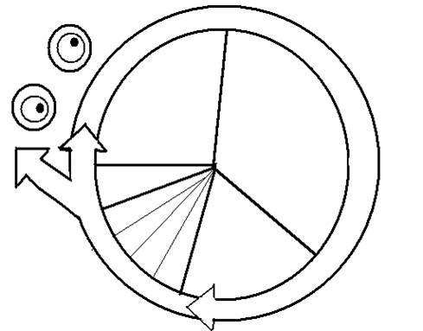
- __________________ , ____________________, and ___________________ are all forms of passive transport. (they do not expect or require energy to work)
- If water passes into a cell, it must be in a _____________________ solution and the process is called ________________.
- A cell can consume a bacterium and bring it inside through the process of _________.
- When an egg and sperm are fertilized, a diploid cell is now formed. This is a blank cell called a stem that the will eventually turn into ________________________.
- An alligator’s egg cell has 14 chromosomes, how many chromosomes will the alligator’s muscle cell have?
- After mitosis, the cells produced are genetically (difference or identical)
- Label the Cell Cycle
- Label the following pictures:

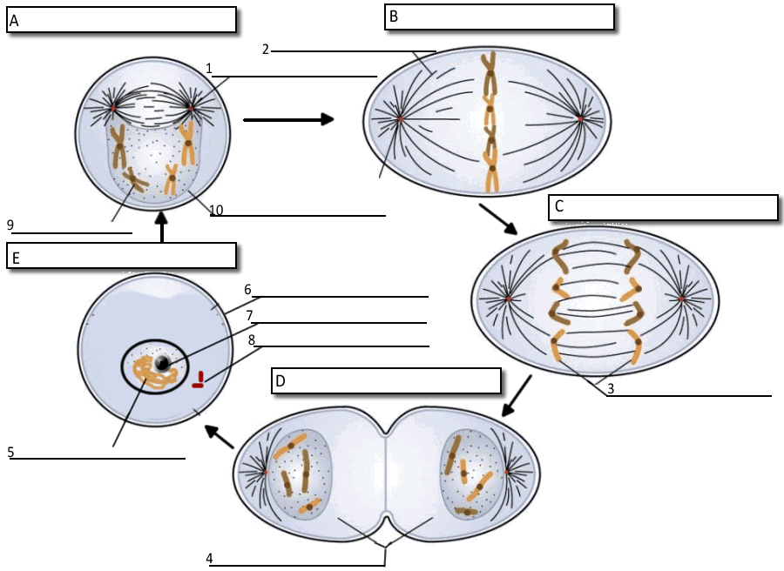

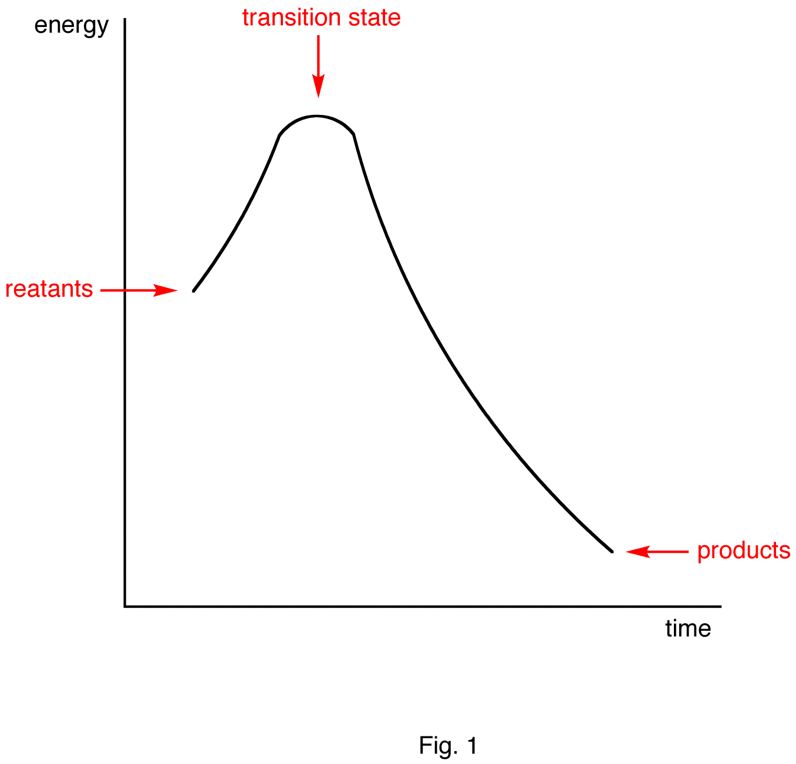

Unit 3: Energy
- _______________ have the highest caloric value per unit.
- _______________ are made up of amino acids.
- Lipids are (polar or non polar)
- Using the following Graph Layout, sketch an endothermic reaction, sketch an exothermic reaction, and pick one of these reactions to show how an enzyme will change the reaction.
- _____________ are biological catalysts
- Reproduction of somatic cells is called __________________.
- _____________ is released when the bond between phosphate groups in ATP is broken.
- Instructions for traits are passed from parent to offspring are known as ___________.
- All energy from used by living things ultimately comes from the __________. In plants they use the chloroplast to turn this energy into chemical energy called ___________. Eukaryotic cells, this energy chemical energy and turn it into ___________.
- __________ is the major atmospheric by product of photosynthesis.
- ________ and _______________ are the products of the light dependent phase of photosynthesis that feed into the Calvin cycle or Light Independent cycle.
- _________ is energy that is essential for a cell to perform all the tasks necessary for life.
- If organisms need to make ATP and there is no oxygen present, it can go through ________________.
- _______________ is a form of muscle soreness.
- List the 3 steps of Cellular Respiration.

