Review Guide for Test: Review of Biology 1

- List the hierarchy of life. Starting with an atom.
____________, _____________, ______________, _______________, ______________, ______________, ____________, _____________, ______________, _______________, ______________, ______________.
- Identify the following organelles and write the function of each organelle.
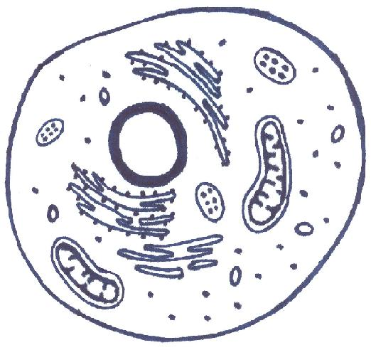
- List 5 of the characteristics of life.
  - __________________ d. _________________
  - __________________ e. _________________
  - __________________
- The cell membrane is made up of _______ layers of ______________________. The phospholipid is made up of a polar ___________, these are water loving, and a _______________ tail, that repels water.
- The cell membranes allows some things like gases and ____________ to move freely as needed but keeps most large items out of the cell until needed.
- Where does crossing over occur? ______________________________________
- __________________ is the study of HOW living things live TOGETHER.
- Write the formula for Photosynthesis. _______________________________________________________________________________________________
  - Where does this process occur? __________________________________________________
- If you were looking at 2 cells. What would you be looking for to see if one of them was a eukaryotic cell?
- What are some differences between Passive and Active transport?
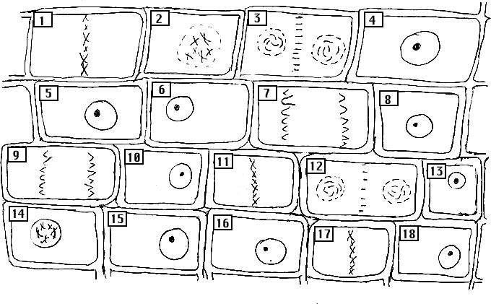
- Using the image of the onion root cells, can you identify the cell that is in Interphase, Prophase, metaphase, anaphase, and telophase.

- Mitosis is the production of two daughter cells that are (genetically identical, genetically different). Meiosis is the production of two cells that are (genetically identical, genetically different)
- In a human, a _______________ has 46 chromosomes and a haploid cell has ______________.
- Write the formula for Cellular Respiration. _________________________________________________________________________________________________
  - Where does it occur? _________________________________________________________________
  - What process occurs if there is not oxygen present? ______________________________
- During which phase is a cell plate produced? __________________
- DNA RNA Amino Acids _______________
- Elephants are normally hairy (HH, Hh). On a rare occasion you will come across an elephant that has very little hair (hh).
  - Genotype for heterozygous hairy elephant. _________________
  - An elephant that is heterozygous for hair reproduces with an elephant that has very little hair. What are the phenotypic ratios of the offspring they could produce?
  - What does it mean if they are “carrying a gene of recessive trait”?
- Are all mutations bad? _________________________________
- What is the difference between meiosis and mitosis? __________________________________________________________________________________________________________
- ___________ is the cell’s instruction for making proteins.
- DNA is normally loose, but coils together to make __________________.
- Replicate the following DNA strand: ATTGCCATA
- Transcribe the following DNA strand : AGGCCTTATAG
- When we are talking about evolution, if an organism can survive, they can ____________ thus producing offspring.
- A ________________ is any change in the DNA sequence that changes the RNA, the amino acid, and the resulting protein.
- What is recombinant DNA? __________________________________________________________________________
- Hybrids, like a liger are often infertile because ____________________________________________.
- Selective breeding can produce things like ______________________, __________________, and ___________________ . (give any 3 example)
- What is the difference between predation and competition? _____________________________________________________________________________________________________
- List some examples of abiotic factors? ____________________, ___________________, and ________________.
  - Biotic? ______________________, ________________________, and _____________________________.

