Station 1: Hormone Cards
Station 2: Reproduction
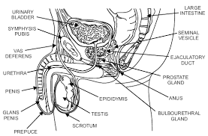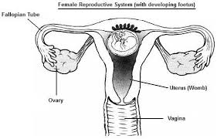

Male:
- Testicle
- Epididymis
- Vas deferens
- Bulbourethral
- Seminal Vesicle
- Testosterone

Female:
- Ovaries
- Uterus
- Fallopian tube
- Egg
- Progesterone
- Estrogen

Station 3: Body review
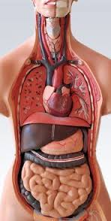
Be able to identify the various structure from the different units and their function in the body.
- Pancreas
- Thyroid
- Thymus
- Parathyroid
- Lungs (bronchus, bronchiole, alveoli)
- Heart
- Pulmonary Vein/Arteries
- Aorta
- Vena Cava
- Trachea
- Larynx

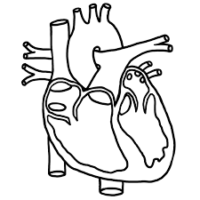
Station 4: Heart labeling
The heart needs to have the following structures and be colored using blue and red colored pencils. You should also draw in arrows.
- Aorta
- Pulmonary vein and artery
- Superior and inferior vena cava
- Left and right ventricle
- Left and right atrium
- Tricuspid valve
- Bicuspid/ mitral valve
- Aortic valve
- Pulmonary valve
- Septum

Station 5: Nervous System
- Using the iPad google Quizlet
- Once on Quizlet search : cavalierib
- The nervous system should be the only cards that appear
http://quizlet.com/

Station 6: Overview of tissues
Using the Websites provided do the review first and then do the histology “lab” to observe the different types of tissues. You can use your drawing in your books to answer the questions instead of redrawing them.
- https://www.wisc-online.com/learn/natural-science/life-science/ap1402/tissue-identification (review)
- http://www.biologycorner.com/anatomy/histology/ (lab)
1. Epithelia are classified by the number of cell layers and the ____________________ of the cells.
2. Distinguish between simple and stratified.
3. Describe the 3 main shapes of epithelial cells
Take the Quiz on a separate sheet of paper and attach to your Worksheet!!!!!!!!!!

