**Unit 1: The Science of Biology**

**An Introduction to Biological Concepts**

The first part of this unit will not be found within the standards of biology. This will be an introduction to biology, and will cover some of the major biological concepts that we will discuss in further detail throughout this semester.

**Scientific Inquiry**

The second part of this unit will be standards-based. It will focus on Standard B-1: Scientific Inquiry. The following explains this standard.

**Scientific Inquiry**

**Standard B – 1: The student will demonstrate an understanding of how scientific inquiry and**

**technological design, including mathematical analysis, can be used**

**appropriately to pose questions, seek answers, and develop solutions.**

There are 9 indicators that are essential for you to be able to understand and/or do.

**B-1.1** Generate hypotheses based on credible, accurate, and relevant sources of scientific

information.

**B-1.2** Use appropriate laboratory apparatuses, technology, and techniques safely and accurately

when conducting a scientific investigation.

**B-1.3** Use scientific instruments to record measurement data in appropriate metric units that reflect

the precision and accuracy of each particular instrument.

**B-1.4** Design a scientific investigation with appropriate methods of control to test a hypothesis

(including independent and dependent variables), and evaluate the designs of sample

investigations.

**B-1.5** Organize and interpret the data from a controlled scientific investigation by using mathematics,

graphs, models, and/or technology.

**B-1.6** Evaluate the results of a controlled scientific investigation in terms of whether they refute or

verify the hypothesis.

**B-1.7** Evaluate a technological design or product on the basis of designated criteria (including cost,

time, and materials).

**B-1.8** Compare the processes of scientific investigation and technological design.

**B-1.9** Use appropriate safety procedures when conducting investigations.

You can expect both quizzes and classwork assignments that will focus on your understanding of the above material. There will also be a Lab Practical in this unit that you will need to pass in order to participate in labs the remainder of the semester. There will be a Unit 1 test upon the completion.

**UNIT 1 TEST: \_\_\_\_\_\_\_\_\_\_\_\_\_\_\_\_\_\_\_\_\_\_\_\_\_\_\_\_\_\_ An Introduction to Biological Concepts**

**Objectives:**

***Define and give examples*** of Earth’s biodiversity.

***Summarize*** the characteristics that all living things share.

***Summarize*** the four major unifying themes of biology.

***Give an example*** of each of the themes of biology.

***Explain*** the importance of clear communication in biology.

**Vocabulary:**

Define the following vocabulary words in the space provided.

1. biosphere

1. biodiversity
2. species
3. biology
4. organism
5. cell

7. metabolism

8. DNA

9. system

10. ecosystem

11. homeostasis

12. evolution

13. adaptation

**What is biology?**

Biology is the study of \_\_\_\_\_\_\_\_\_\_\_\_\_\_.

We study biology to learn about the \_\_\_\_\_\_\_\_\_\_ around \_\_\_\_\_\_\_.

Life is made up of \_\_\_\_\_\_\_\_\_\_\_\_ particles, so we study them.

**Why do we study biology?**

1.

2.

3.

4.

Were it not for the study of biology, there would be none of the following:

Advancements in \_\_\_\_\_\_\_\_\_\_\_\_\_\_.

Think of an example:

Advancements in \_\_\_\_\_\_\_\_\_\_\_\_\_\_\_.

Think of an example:

Advancements in \_\_\_\_\_\_\_\_\_\_\_\_\_\_\_.

Think of an example:

Advancements in our basic \_\_\_\_\_\_\_\_\_\_\_\_\_\_\_\_\_\_\_\_ of the world \_\_\_\_\_\_\_\_\_\_\_\_ us.

When we study biology, we are not only studying living things.

We learn how a \_\_\_\_\_\_\_\_\_ operates.

We learn how to use the \_\_\_\_\_\_\_\_\_\_\_\_\_ \_\_\_\_\_\_\_\_\_\_\_\_.

We learn how to properly \_\_\_\_\_\_\_\_\_\_\_ and \_\_\_\_\_\_\_\_\_\_ data.

We learn how to \_\_\_\_\_\_\_\_\_\_\_\_ new knowledge to new or existing \_\_\_\_\_\_\_\_\_\_\_\_\_.

We \_\_\_\_\_\_\_\_ our understanding of things (both \_\_\_\_\_\_\_\_\_ & \_\_\_\_\_\_\_\_\_\_) around us.

**What is Life?**

The \_\_\_\_\_\_\_\_\_\_\_\_\_ includes all living things & all the places they are found.

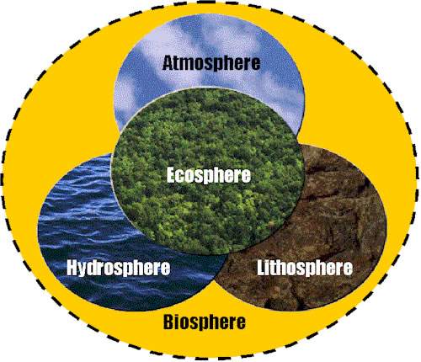Every part of the \_\_\_\_\_\_\_\_\_\_\_\_ is connected with every other part.

The \_\_\_\_\_\_\_\_\_\_ includes many environments.

Lithosphere (land/terrestrial)

Hydrosphere (saltwater and freshwater)

Atmosphere (air)

The term \_\_\_\_\_\_\_\_\_\_\_\_\_ refers to the variety of life in an area.

\_\_\_\_\_\_\_\_\_\_\_\_ greatly increases as you move from the poles.

\_\_\_\_\_\_\_\_\_\_\_\_\_ is greater in areas with consistently warm temperatures.

A \_\_\_\_\_\_\_\_\_\_\_\_\_\_\_ is one particular type of living thing, an \_\_\_\_\_\_\_\_\_\_\_\_\_\_\_\_.

Members of a \_\_\_\_\_\_\_\_\_\_\_\_\_ can interbreed to reproduce.

 There are about \_\_\_\_\_\_\_\_\_\_\_\_\_\_ species that have been identified.

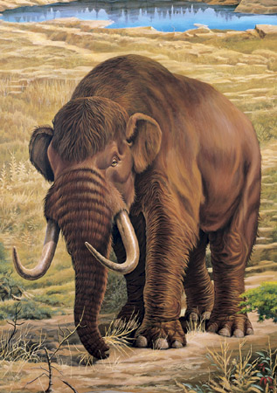

99% of the species that were ever on earth are not extinct like the Wooly Mammoth to the left.

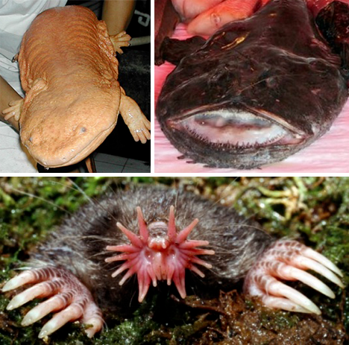

There are also many species on earth that are very unusual, like the ones to the right. Write some of them down in the space below and read about them later.

**CHARACTERISTICS OF LIFE**

All living things share certain characteristics whether they are small and simple or large and complex.

1) All living things \_\_\_\_\_\_\_\_\_\_\_\_\_\_\_\_\_\_\_\_\_\_\_\_\_\_\_\_\_\_\_\_\_\_\_\_\_\_\_\_\_\_\_\_\_\_\_\_\_\_\_\_\_.

* 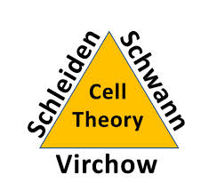A \_\_\_\_\_\_\_\_ is the basic unit of life. The \_\_\_\_\_\_ \_\_\_\_\_\_\_\_\_ states that:

1. All living things are composed of \_\_\_\_\_\_\_ or \_\_\_\_\_\_\_ cells.

2. Cells are the basic unit of \_\_\_\_\_\_\_\_\_\_\_\_and \_\_\_\_\_\_\_\_\_\_\_\_\_\_

in living things.

3. All cells come from \_\_\_\_\_\_\_\_\_\_ cells.

* Cells come in \_\_\_\_\_\_\_ \_\_\_\_\_\_\_\_\_ categories.
* Eukaryotes contain a \_\_\_\_\_\_\_\_ \_\_\_\_\_\_\_\_\_\_\_. This means the DNA is \_\_\_\_\_\_\_\_\_\_\_\_\_\_\_ in a membrane. They also contain membrane-bound \_\_\_\_\_\_\_\_\_\_\_\_\_\_\_\_\_\_\_\_\_.
* Prokaryotes \_\_\_\_\_\_\_\_\_ contain a true-nucleus. This means the DNA \_\_\_\_\_\_\_\_\_\_\_\_\_\_\_\_\_\_ \_\_\_\_\_\_\_\_\_\_\_\_\_\_\_ in the cytoplasm. They also \_\_\_\_\_\_\_\_\_\_\_\_\_\_\_\_\_ contain membrane-bound organelles.

2) All living things \_\_\_\_\_\_\_\_\_\_\_\_\_\_\_\_\_\_\_\_\_\_\_\_\_\_\_\_\_\_\_\_\_\_\_\_\_\_\_\_\_\_\_\_\_\_\_\_\_\_\_\_.

* Reproduction is important for the \_\_\_\_\_\_\_\_\_\_\_\_\_\_\_ of a species.
* Organisms can reproduce in one of two ways:

1. \_\_\_\_\_\_\_\_\_\_\_\_\_\_\_\_\_\_\_\_
2. \_\_\_\_\_\_\_\_\_\_\_\_\_\_\_\_\_\_\_\_

|  |  |
| --- | --- |
| **Asexual** | **Sexual** |
| Offspring \_\_\_\_\_\_\_\_\_\_\_\_ \_\_\_\_\_\_\_\_\_\_\_\_\_ to parent and each other. | Offspring \_\_\_\_\_\_\_\_\_\_\_\_\_\_ \_\_\_\_\_\_\_\_\_\_\_\_\_\_ to parent and each other. |
| \_\_\_\_\_\_\_\_\_ fitness for natural selection; \_\_\_\_\_\_\_\_\_\_\_\_\_ genetic variety. | \_\_\_\_\_\_\_\_\_\_\_\_\_ fitness for natural selection; \_\_\_\_\_\_\_\_\_\_\_\_\_ genetic variety. |
| \_\_\_\_\_\_ \_\_\_\_\_\_\_\_\_\_\_\_\_\_\_\_\_\_\_\_\_. Binary \_\_\_\_\_\_\_\_\_\_\_\_, Budding, and Fragmentation are examples. | \_\_\_\_\_\_\_\_\_\_\_\_\_\_\_ of sperm and egg (\_\_\_\_\_\_\_\_\_\_). |
| \_\_\_\_\_\_\_\_\_\_\_\_\_\_ reproduction rate; doesn’t require a partner. | \_\_\_\_\_\_\_\_\_\_\_ reproduction rate; requires a partner. |

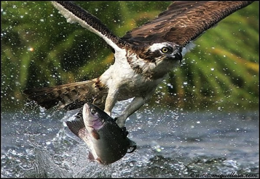3) All living things \_\_\_\_\_\_\_\_\_\_\_\_\_\_\_\_\_\_\_\_\_\_\_\_\_\_\_\_\_\_\_\_\_\_\_\_\_\_\_\_\_\_\_\_\_\_\_\_\_\_\_\_\_.

* \_\_\_\_\_\_\_\_\_\_\_ = \_\_\_\_\_\_\_\_\_\_\_\_ = \_\_\_\_\_\_\_\_\_\_\_\_\_
* Organisms can acquire energy in one of two ways:
  + Some organisms can MAKE their own energy. They are called \_\_\_\_\_\_\_\_\_\_\_\_\_\_\_\_. Some have pigments called \_\_\_\_\_\_\_\_\_\_\_\_\_\_\_ that can absorb energy from the sun in a process called \_\_\_\_\_\_\_\_\_\_\_\_\_\_\_\_\_\_. Others can convert organic \_\_\_\_\_\_\_\_\_\_\_\_ into useable energy in a process called \_\_\_\_\_\_\_\_\_\_\_\_\_\_\_\_\_\_.
  + Some organisms CANNOT make their own energy. They are called \_\_\_\_\_\_\_\_\_\_\_\_\_\_\_\_. They must \_\_\_\_\_\_\_\_\_\_\_\_\_ other organisms for their food.

4) All living things \_\_\_\_\_\_\_\_\_\_\_\_\_\_\_\_\_\_\_\_\_\_\_\_\_\_\_\_\_\_\_\_\_\_\_\_\_\_\_\_\_\_\_\_\_\_\_\_\_\_\_\_\_\_\_\_.

* 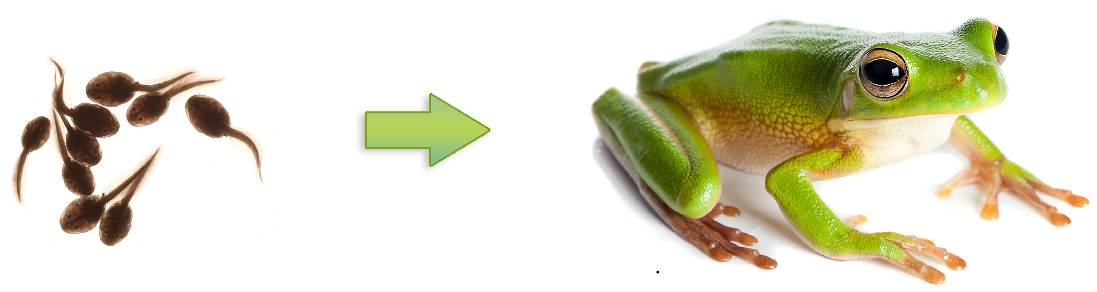For a unicellular organism to grow, it must increase its volume of \_\_\_\_\_\_\_\_\_\_\_\_ - increase in amount of cytosol (the liquid) and number of \_\_\_\_\_\_\_\_\_\_\_\_\_\_ (the machinery).
* For a multicellular organism to grow, it must undergo \_\_\_\_\_\_\_ \_\_\_\_\_\_\_\_\_\_\_\_ and \_\_\_\_\_\_\_\_\_\_\_\_\_\_\_\_\_\_\_\_\_\_\_\_\_\_\_\_\_\_\_\_.
  + Cell Division:
    - \_\_\_\_\_\_\_\_\_ cells undergo \_\_\_\_\_\_\_\_\_\_
    - \_\_\_\_\_\_\_\_\_ cells undergo \_\_\_\_\_\_\_\_\_\_
  + Specialization / Differentiation
    - Processing a \_\_\_\_\_\_\_\_ \_\_\_\_\_\_\_\_ (Ex. heart cell vs. brain cell)

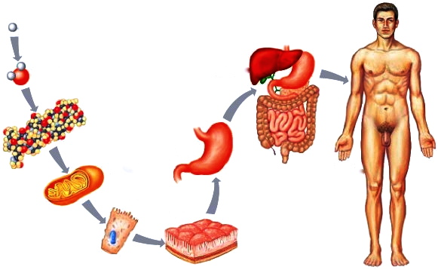5) All living things \_\_\_\_\_\_\_\_\_\_\_\_\_\_\_\_\_\_\_\_\_\_\_\_\_\_\_\_\_\_\_\_\_\_\_\_\_\_\_\_\_\_\_\_\_\_\_\_\_\_\_\_\_.

6) All living things \_\_\_\_\_\_\_\_\_\_\_\_\_\_\_\_\_\_\_\_\_\_\_\_\_\_\_\_\_\_\_\_\_\_\_\_\_\_\_\_\_\_\_\_\_\_\_\_\_\_\_\_\_.

* 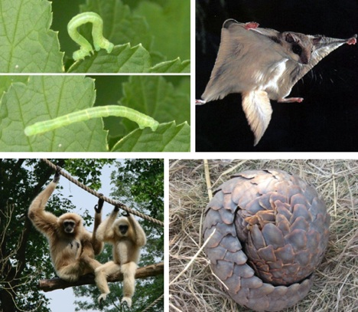Organisms that CAN move on their own exhibit movement called \_\_\_\_\_\_\_\_\_\_\_\_\_\_\_\_\_\_.
* Organisms that CANNOT move on their own exhibit movement called \_\_\_\_\_\_\_\_\_\_\_\_ \_\_\_\_\_\_\_\_\_\_\_\_\_\_\_\_.

7) All living things \_\_\_\_\_\_\_\_\_\_\_\_\_\_\_\_\_\_\_\_\_\_\_\_\_\_\_\_\_\_\_\_\_\_\_\_\_\_\_\_\_\_\_\_\_\_\_\_\_\_\_\_\_.

* All living things respond to changes, \_\_\_\_\_\_\_\_\_\_\_, in their environment.
* 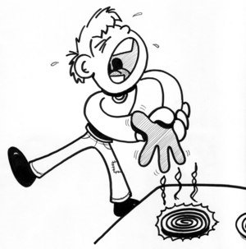This stimuli can either be in their \_\_\_\_\_\_\_\_\_\_\_\_\_\_ environment or their \_\_\_\_\_\_\_\_\_\_\_\_\_ environment.
* 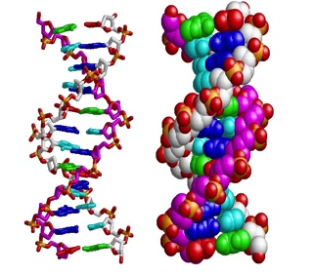This response to stimuli brings the organism back to equilibrium or \_\_\_\_\_\_\_\_\_\_\_\_\_\_, which is a \_\_\_\_\_\_\_\_\_\_\_\_\_ internal environment.

8) All living things \_\_\_\_\_\_\_\_\_\_\_\_\_\_\_\_\_\_\_\_\_\_\_\_\_\_\_\_\_\_\_\_\_\_\_\_\_\_\_\_\_\_\_\_\_\_\_\_.

* This genetic information is in the form of \_\_\_\_\_\_\_\_.
* DNA stands for \_\_\_\_\_\_\_\_\_\_\_\_\_\_\_\_\_\_\_\_\_ \_\_\_\_\_\_\_\_\_.
* 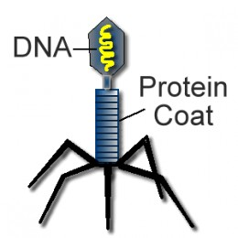Viruses also contain genetic information. They either have DNA or \_\_\_\_\_\_\_\_ (in retroviruses. However, viruses are considered \_\_\_\_\_\_\_\_\_\_\_\_\_\_\_, because they do not exhibit some of the other characteristics of living things.

9) All living things \_\_\_\_\_\_\_\_\_\_\_\_\_\_\_\_\_\_\_\_\_\_\_\_\_\_\_\_\_\_\_\_\_\_\_\_\_\_\_\_\_\_\_\_\_\_.

* 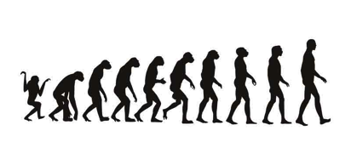The British naturalist, \_\_\_\_\_\_\_\_\_\_ \_\_\_\_\_\_\_\_\_\_\_\_, is considered the Father of \_\_\_\_\_\_\_\_\_\_\_\_\_\_\_ \_\_\_\_\_\_\_\_\_\_\_\_\_\_. His theory is based on the mechanism of \_\_\_\_\_\_\_\_\_\_\_\_\_\_ \_\_\_\_\_\_\_\_\_\_\_\_\_\_\_.
* Due to \_\_\_\_\_\_\_\_\_\_\_\_\_\_ in the DNA, organisms will differ in genetically determined traits, thus slowly becoming different \_\_\_\_\_\_\_\_\_\_\_\_\_.
* Those with favorable traits are better \_\_\_\_\_\_\_\_\_\_\_\_\_\_ to their environment therefore LIVE LONGER and REPRODUCE more often. They have a higher \_\_\_\_\_\_\_\_\_\_\_\_\_\_.

**What are the unifying themes of biology?**

**How do we communicate in Biology?**

In order for scientists all over the world to understand one another, science is rooted in Latin and relies heavily on prefixes and suffixes.

**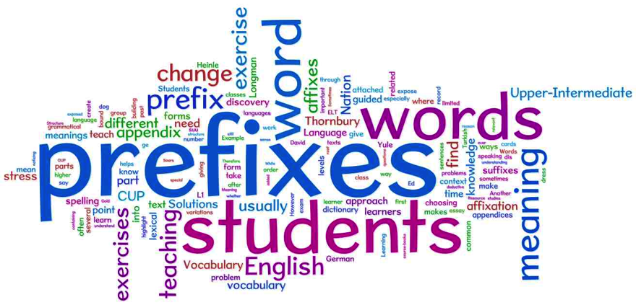**

**Scientific Inquiry**

**Standard B – 1: The student will demonstrate an understanding of how scientific inquiry and**

**technological design, including mathematical analysis, can be used**

**appropriately to pose questions, seek answers, and develop solutions.**

*Indicator B – 1.1: Generate hypotheses on the basis of credible, accurate, and relevant*

*sources of scientific information.*

**Objectives:**

***Identify***the variables involved in a hypothesis.

***Use*** data to determine whether a hypothesis is supported or not supported by the data.

***Summarize*** the criteria by which scientific information is used to help generate hypotheses.

**Vocabulary Words:**

Define the following vocabulary words in the space provided.

1. hypothesis
2. independent variable
3. dependent variable

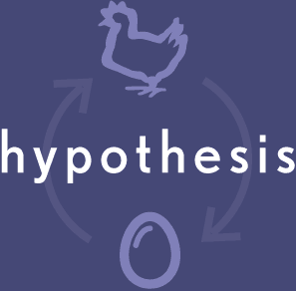**\*\*\*\*\*\*\*\*\*\*\*\*\*\*\*\*\*\*\*\*\*\*\*\*\*\*\*\*\*\*\*\*\*\*\*\*\*\*\*\*\*\*\*\*\*\*\*\*\*\*\*\*\*\*\*\*\*\*\*\*\*\*\*\*\*\*\*\*\*\*\*\*\*\*\*\*\*\*\*\*\*\*\*\*\*\*\*\*\*\*\*\*\*\*\*\*\*\*\*\*\*\*\*\*\*\*\*\*\*\*\*\*\*\*\***

**What is a hypothesis?**

A \_\_\_\_\_\_\_\_\_\_\_\_\_\_ is often referred to as an “educated guess”.

Why is it called an *educated guess* vs. just a *guess*?

A \_\_\_\_\_\_\_\_\_\_\_\_\_\_ is a possible explanation of why something

may have happened or a prediction of what might happen. It is the

explanation of the possible cause of a problem or a possible solution to a problem.

The \_\_\_\_\_\_\_\_\_\_\_\_\_\_\_ may or may not be supported by the experimental results.

* It is often stated in terms of an independent and a dependent variable .
  + - Cause and Effect Relationship
    - “If….then….because…”

The results of an experiment CANNOT prove a hypothesis is correct. Instead, the results of an experiment **support or do not support the hypothesis**.

When hypotheses are tested over and over again and not contradicted, they may become known as \_\_\_\_\_\_\_\_\_\_ or \_\_\_\_\_\_\_\_\_\_\_.

**Example**: Imagine that you are sitting at home, watching television, and suddenly, your lights

go out. What would you do?

The first thing you need to figure out is:

This is called forming a \_\_\_\_\_\_\_\_\_\_\_\_\_. In order for it to be a true \_\_\_\_\_\_\_\_\_\_\_\_\_\_, it must be able to be \_\_\_\_\_\_\_\_\_\_\_\_\_\_.

**Hypotheses**

are

formulated, stated, formed, or framed

then they are

tested

then they are

**or**

accepted, verified rejected or disproved

or confirmed

**Question and Hypothesis Practice**

A student is interested in designing several experiments to test the factors that effect how quickly an

Alka-Seltzer® tablet dissolves in water (solution rate). For each question, write an appropriate

hypothesis that could be tested with an experiment. Be sure each hypothesis is in the proper *“If…,*

*then… , because…”* format.

**Example:**

*Question***:** What effect does stirring have on solution rate?

*Hypothesis***:** If the water is stirred, then the tablet will dissolve faster because stirring increases

solution rate.

1. *Question*: What effect does the water temperature have on solution rate?

*Hypothesis*: \_\_\_\_\_\_\_\_\_\_\_\_\_\_\_\_\_\_\_\_\_\_\_\_\_\_\_\_\_\_\_\_\_\_\_\_\_\_\_\_\_\_\_\_\_\_\_\_\_\_\_\_\_\_\_\_\_\_\_\_\_\_\_\_\_\_\_\_\_

\_\_\_\_\_\_\_\_\_\_\_\_\_\_\_\_\_\_\_\_\_\_\_\_\_\_\_\_\_\_\_\_\_\_\_\_\_\_\_\_\_\_\_\_\_\_\_\_\_\_\_\_\_\_\_\_\_\_\_\_\_\_\_\_\_\_\_\_\_\_\_\_\_\_\_\_\_\_\_\_

2. *Question*: What effect does crushing the tablet have on solution rate?

*Hypothesis*: \_\_\_\_\_\_\_\_\_\_\_\_\_\_\_\_\_\_\_\_\_\_\_\_\_\_\_\_\_\_\_\_\_\_\_\_\_\_\_\_\_\_\_\_\_\_\_\_\_\_\_\_\_\_\_\_\_\_\_\_\_\_\_\_\_\_\_\_\_

\_\_\_\_\_\_\_\_\_\_\_\_\_\_\_\_\_\_\_\_\_\_\_\_\_\_\_\_\_\_\_\_\_\_\_\_\_\_\_\_\_\_\_\_\_\_\_\_\_\_\_\_\_\_\_\_\_\_\_\_\_\_\_\_\_\_\_\_\_\_\_\_\_\_\_\_\_\_\_\_

3. Question: What effect does adding soda to the water have on solution rate?

*Hypothesis*: \_\_\_\_\_\_\_\_\_\_\_\_\_\_\_\_\_\_\_\_\_\_\_\_\_\_\_\_\_\_\_\_\_\_\_\_\_\_\_\_\_\_\_\_\_\_\_\_\_\_\_\_\_\_\_\_\_\_\_\_\_\_\_\_\_\_\_\_\_

\_\_\_\_\_\_\_\_\_\_\_\_\_\_\_\_\_\_\_\_\_\_\_\_\_\_\_\_\_\_\_\_\_\_\_\_\_\_\_\_\_\_\_\_\_\_\_\_\_\_\_\_\_\_\_\_\_\_\_\_\_\_\_\_\_\_\_\_\_\_\_\_\_\_\_\_\_\_\_\_

\*\*\*\*\*\*\*\*\*\*\*\*\*\*\*\*\*\*\*\*\*\*\*\*\*\*\*\*\*\*\*\*\*\*\*\*\*\*\*\*\*\*\*\*\*\*\*\*\*\*\*\*\*\*\*\*\*\*\*\*\*\*\*\*\*\*\*\*\*\*\*\*\*\*\*\*\*\*\*\*\*\*\*\*\*\*\*\*\*\*

## ****Use valid, credible sources for information****

Just because you have located a book, article, website, or other resource on your topic, does not mean you should automatically use it in your paper or project. You need to choose your resources carefully to make sure you get the best and most useful ones.

How can you tell if the book, article, website, or other resource you located is a valid, credible source?  It may be helpful for you to ask yourself six questions:

|  |  |
| --- | --- |
| Who? | Who is the author?  What are his/her credentials? |
| What? | What information is available from this resource? |
| Where? | Where did the author(s) get the information?  Are citations provided? |
| When? | When was the resource produced?  (For books, check the copyright date.  For articles, check the publication date.  For websites, look for a "created on" or "last updated on" date.) |
| Why? | Why does this resource exist?  Is the purpose to entertain, persuade, inform, etc.?  Is the resource biased? |
| How? | How comprehensive is the resource?   Does it go into the depth you need? |

**Scientific Inquiry**

**Standard B – 1: The student will demonstrate an understanding of how scientific inquiry**

**and technological design, including mathematical analysis, can be used**

**appropriately to pose questions, seek answers, and develop solutions.**

*Indicator B – 1.2: Use appropriate laboratory apparatuses, technology, and techniques*

*safely and accurately when conducting a scientific investigation.*

*Indicator B – 1:9: Use appropriate safety procedures when conducting investigations.*

**Objectives:**

***Identify*** an apparatus from a description or illustration.

***Recognize*** appropriate laboratory apparatuses, technology, & techniques for given procedures

***Recognize*** safety guidelines associated with use of laboratory apparatuses, technology, and

techniques.

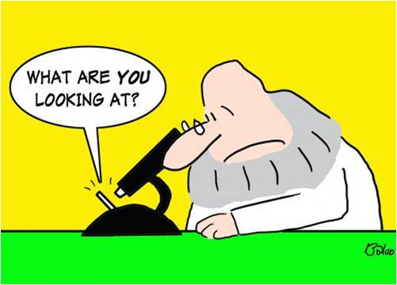**Vocabulary Words:**

Define the following vocabulary words in the space provided.

1. microscope

**\*\*\*\*\*\*\*\*\*\*\*\*\*\*\*\*\*\*\*\*\*\*\*\*\*\*\*\*\*\*\*\*\*\*\*\*\*\*\*\*\*\*\*\*\*\*\*\*\*\*\*\*\*\*\*\*\*\***

**Lab Safety**

One of the first things a scientist learns is how a lab operates. This includes being safe in the lab. While working in the lab

can be very exciting, it can also be very dangerous if proper safety rules are not followed

correctly.

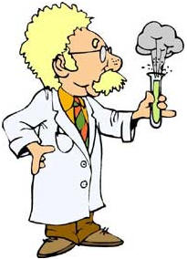

Using your textbook, find the pages that discuss proper lab safety and provide pictures of lab safety symbols. Write those page numbers BIG in the space below.

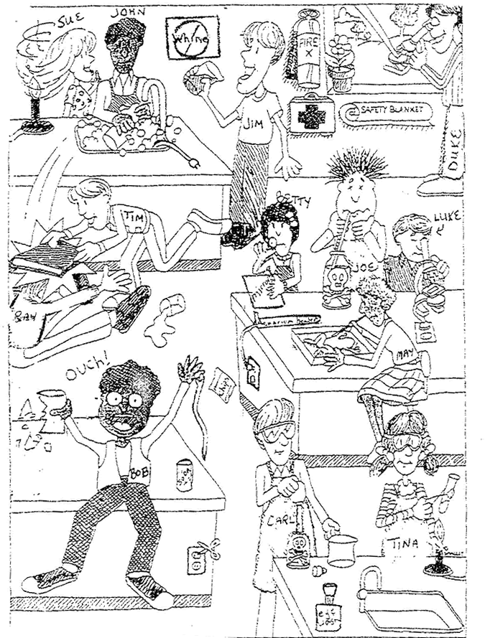Look at the picture to the right. List 5 things that you see as safety violations or not acceptable as safe practice in the science lab.

1.

2.

3.

4.

5.

In order to participate in laboratory activities, a **Lab Safety Contract** must be signed.

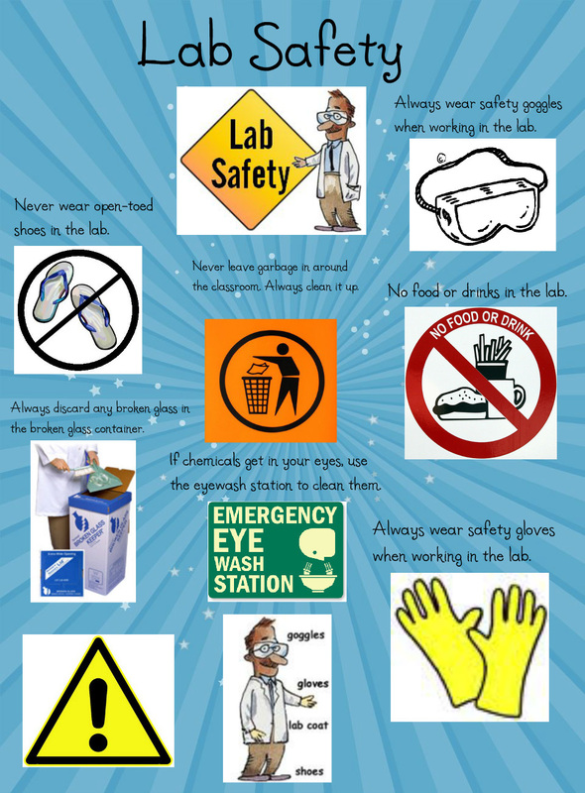

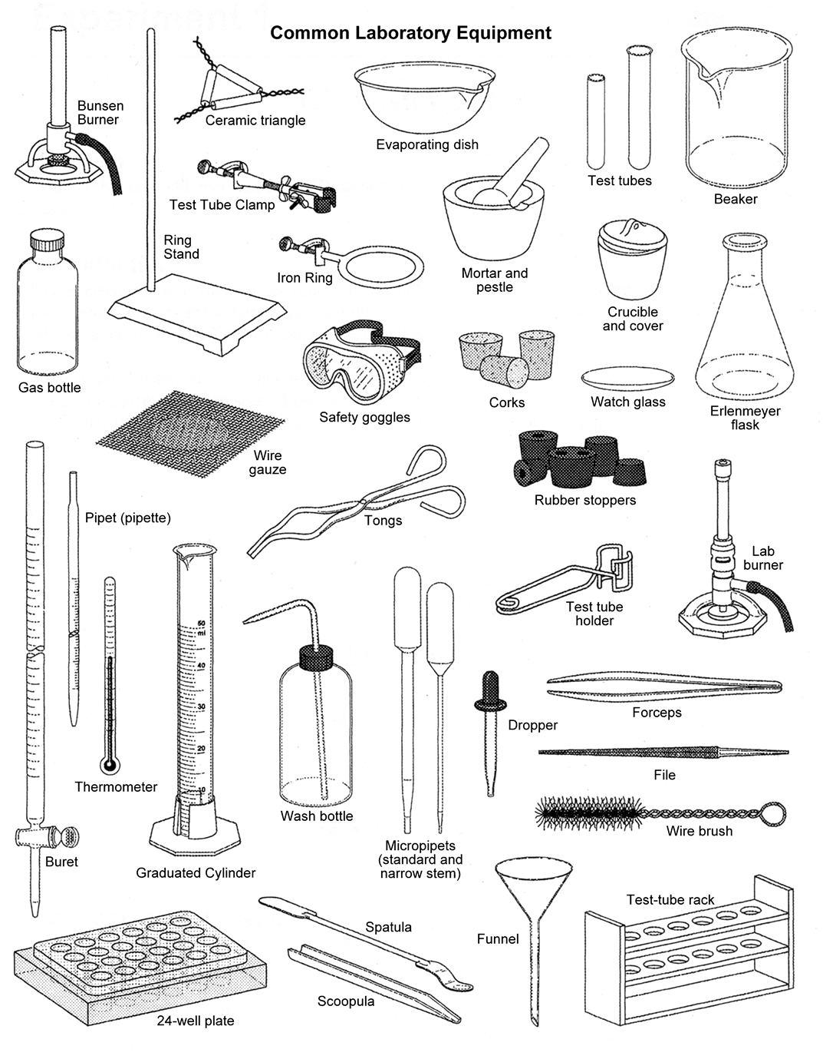

1. Which piece of laboratory equipment would be used to measure volume precisely?
2. Which laboratory apparatus would be used to pour liquids into containers with small openings?
3. Which piece of laboratory equipment would be used to heat an object?
4. Which laboratory apparatus would require you to use °C?
5. Which laboratory apparatus would require you to use a rubber stopper to prevent a liquid from spilling?
6. Which laboratory apparatus would be used for protection during an investigation?
7. Which is a wide-mouthed piece of laboratory apparatus used to store, transport, and heat substances?
8. Which piece of laboratory equipment would be used to place test-tubes being used during a scientific investigation?
9. What laboratory apparatus is used to clean out a test-tube?
10. Which piece of laboratory equipment is used to scoop small substances?

To the left is a picture of common laboratory equipment (apparatuses) used in science. You will need to study this laboratory equipment.

Below are descriptions of how various pieces are used. Answer each question, using the equipment found here.

Record your answers in the space below.

**1.**

**2.**

**3.**

**4.**

**5.**

**6.**

**7.**

**8.**

**9.**

**10.**

**Microscopes**

Tools are objects used to improve the performance of a task.

\_\_\_\_\_\_\_\_\_\_\_ are tools that extend human vision by making enlarged images of objects:

\* Compound light microscope

\* Scanning electron microscope (SEM)

\* Transmission electron microscope (TEM)

\* Dissecting microscope

|  |  |  |  |
| --- | --- | --- | --- |
| **Compound Light**  **Microscope**  **(CLM)** | **Scanning Electron Microscope**  **(SEM)** | **Transmission Electron Microscope**  **(TEM)** | **Dissecting**  **Microscope** |
|  |  |  |  |

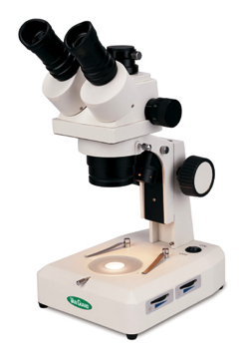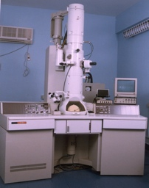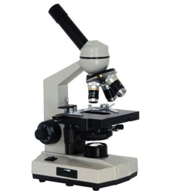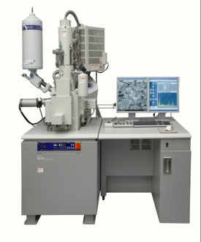

**Scientific Inquiry**

**Standard B – 1: The student will demonstrate an understanding of how scientific inquiry and**

**technological design, including mathematical analysis, can be used**

**appropriately to pose questions, seek answers, and develop solutions.**

*Indicator B – 1.3: Use scientific instruments to record measurement data in appropriate metric*

*units that reflect the precision and accuracy of each particular instrument.*

**Objectives:**

***Compare*** precise vs. accurate measurement data.

***Summarize***accuracy & precision with specific scientific instruments in making measurements.

***Identify*** the appropriate instrument that meets the measurement need and appropriate

precision for a designed experiment.

**Vocabulary Words:**

There are no vocabulary words for this topic.

**\*\*\*\*\*\*\*\*\*\*\*\*\*\*\*\*\*\*\*\*\*\*\*\*\*\*\*\*\*\*\*\*\*\*\*\*\*\*\*\*\*\*\*\*\*\*\*\*\*\*\*\*\*\*\*\*\*\*\*\*\*\*\*\*\*\*\*\*\*\*\*\*\*\*\*\*\*\*\*\*\*\*\*\*\*\*\*\*\*\*\*\*\*\*\*\*\*\*\*\*\*\*\*\*\*\*\*\*\*\*\*\*\*\*\*\*\*\*\*\*\*\*\*\*\*\***

**Measurement**

\_\_\_\_\_\_\_\_\_\_\_\_ is an important type of observation. It is an observation that includes numbers & units.

In science, we use the SI System, commonly referred to as the \_\_\_\_\_\_\_\_\_\_\_ \_\_\_\_\_\_\_\_\_\_\_\_\_

> Based on multiples of \_\_\_\_\_\_\_\_\_\_\_

> Prefixes before the base

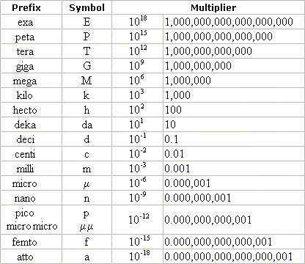It’s very important to know which prefix you use. Let’s practice.

1. height of a tree

2. mass of a hamster

3. volume of an aquarium

4. length of a small insect

5. mass of an insect

6. volume of a graduated cylinder

7. temperature of a classroom

8. length of a microscopic organism

9.mass of an elephant

10. speed of a car

11. length of a test tube

a. centimeter e. kilometers per hour i. milligram

b. degrees Celsius f. liter j. milliliter

c. gram g. meter k. millimeter

d. kilogram h. micron

**What if I want to convert between units?**

\_\_\_\_\_\_\_\_\_\_\_ \_\_\_\_\_\_\_\_\_\_\_\_\_ is a way to convert

**WHAT YOU WANT**

**WHAT YOU HAVE**

measurements between different units to help compare them.

Dimensional analysis is also called the *factor-label method* of problem solving. It is a way of setting up a problem in a constant fashion that breaks the problem down into simple steps. Each step is a ratio that **must equal 1**, thus canceling out some preceding unit.

**Example:**

4.4 km = \_\_\_\_\_ m

solution: 4.4 km x 1000 m = 4,400 m (note the “km” cancel each other out)

1 km

Using dimensional analysis, solve the following. Show your work.

1. 11 mm = \_\_\_\_\_\_\_\_\_ cm
2. 261 g = \_\_\_\_\_\_\_\_\_\_\_\_ kg

3. 9,474 mm = \_\_\_\_\_\_\_\_\_\_\_\_ cm

**Precision vs. Accuracy**

It is important to understand both *precision* and *accuracy* in scientific measurements.

\_\_\_\_\_\_\_\_\_\_\_\_ is the amount of detail in measurements, or how closely two or more measurements agree. For example, a ruler marked in millimeters measures more precise than one marked in centimeters.

\_\_\_\_\_\_\_\_\_\_\_\_\_ is how close a measurement is to the actual or accepted value for that measurement. To improve accuracy, scientists in different laboratories often measure the same thing several times.

The following example compares precision and accuracy. The charts contain data recorded by two students. Each student measured the mass and volume of the same sample of muscle tissue three times.

**Table 1: Density of a Muscle Tissue Sample Table 2: Density of a Muscle Tissue Sample**

|  |  |  |
| --- | --- | --- |
| **Mass** | **Volume** | **Density** |
| 0.02 kg | 0.013 L | 1.5 kg/L |
| 0.02 kg | 0.018 L | 1.1 kg/L |
| 0.02 kg | 0.016 L | 1.3 kg/L |

|  |  |  |
| --- | --- | --- |
| **Mass** | **Volume** | **Density** |
| 0.016 kg | 0.013 L | 1.2 kg/L |
| 0.019 kg | 0.017 L | 1.1 kg/L |
| 0.016 kg | 0.015 L | 1.1 kg/L |

Table 1 shows mass measured to the nearest hundredth of a kilogram, whereas Table 2 shows mass measured to the nearest thousandth of a kilogram. Which student’s measurements of mass are more precise?

Both students measured volume to the nearest thousandth of a liter. Notice that the range of the results (the difference between the highest and lowest values) in Table 1 is greater than in Table 2. Which students measurements of volume are more precise?

Density is the ratio of mass to volume. The actual density of the sample was 1.05 kg/L. Which student’s measurements were more accurate?

**Lab Practical**

Your task will be to successfully navigate through the lab, completing each task successfully. Each task does NOT have to be done in order. You must complete each one.

**Task 1: Temperature**

**Liquid A: \_\_\_\_\_\_\_\_\_\_ Liquid B: \_\_\_\_\_\_\_\_\_\_\_\_\_**

**Task 2: Volume**

**A B**

**Task 3: Mass**

**Object A: \_\_\_\_\_\_\_\_\_\_\_\_\_\_ Object B: \_\_\_\_\_\_\_\_\_\_\_\_\_**

**Task 4: Length**

1. How many cm are on a meter stick? \_\_\_\_\_\_\_\_\_\_\_\_\_\_\_\_\_

2. How many mm are on a meter stick? \_\_\_\_\_\_\_\_\_\_\_\_\_\_\_\_

3. How many meters are found on a meter stick? \_\_\_\_\_\_\_\_\_\_\_\_\_ (Hint: Think!!)

4. Measure the following:

length of the sink: \_\_\_\_\_\_\_\_\_\_\_\_\_\_\_\_\_\_\_\_\_\_\_\_\_\_\_\_\_\_

width of the sink: \_\_\_\_\_\_\_\_\_\_\_\_\_\_\_\_\_\_\_\_\_\_\_\_\_\_\_\_\_\_

height of the sink: \_\_\_\_\_\_\_\_\_\_\_\_\_\_\_\_\_\_\_\_\_\_\_\_\_\_\_\_\_

Find the area of the sink (L x W): \_\_\_\_\_\_\_\_\_\_\_\_\_\_\_\_\_\_\_\_\_\_\_\_\_\_\_\_\_

**Task 5: Lab Equipment Identification**

1. \_\_\_\_\_\_\_\_\_\_\_\_\_\_\_\_\_\_\_\_\_\_\_\_\_ 5. \_\_\_\_\_\_\_\_\_\_\_\_\_\_\_\_\_\_\_\_\_\_\_\_ 9. \_\_\_\_\_\_\_\_\_\_\_\_\_\_\_\_\_\_\_\_\_\_\_\_\_ 2. \_\_\_\_\_\_\_\_\_\_\_\_\_\_\_\_\_\_\_\_\_\_\_\_ 6. \_\_\_\_\_\_\_\_\_\_\_\_\_\_\_\_\_\_\_\_\_\_\_\_\_ 10. \_\_\_\_\_\_\_\_\_\_\_\_\_\_\_\_\_\_\_\_\_\_\_\_

3. \_\_\_\_\_\_\_\_\_\_\_\_\_\_\_\_\_\_\_\_\_\_\_\_\_ 7. \_\_\_\_\_\_\_\_\_\_\_\_\_\_\_\_\_\_\_\_\_\_\_\_ 11. \_\_\_\_\_\_\_\_\_\_\_\_\_\_\_\_\_\_\_\_\_\_\_\_\_ 4. \_\_\_\_\_\_\_\_\_\_\_\_\_\_\_\_\_\_\_\_\_\_\_\_ 8. \_\_\_\_\_\_\_\_\_\_\_\_\_\_\_\_\_\_\_\_\_\_\_\_\_ 12. \_\_\_\_\_\_\_\_\_\_\_\_\_\_\_\_\_\_\_\_\_\_\_\_

**Task 6: Safety Hunt**

1. \_\_\_\_\_\_\_\_\_\_\_\_\_\_\_\_\_\_\_\_\_\_\_\_\_ 4. \_\_\_\_\_\_\_\_\_\_\_\_\_\_\_\_\_\_\_\_\_\_\_\_

2. \_\_\_\_\_\_\_\_\_\_\_\_\_\_\_\_\_\_\_\_\_\_\_\_\_ 5. \_\_\_\_\_\_\_\_\_\_\_\_\_\_\_\_\_\_\_\_\_\_\_\_

3. \_\_\_\_\_\_\_\_\_\_\_\_\_\_\_\_\_\_\_\_\_\_\_\_\_ 6. \_\_\_\_\_\_\_\_\_\_\_\_\_\_\_\_\_\_\_\_\_\_\_\_

**Task 7: Teacher Signature** \_\_\_\_\_\_\_\_\_\_\_\_\_\_\_\_\_\_\_\_\_\_\_\_\_\_\_\_\_\_\_\_\_\_\_\_\_\_\_\_\_\_\_\_\_\_\_\_\_\_\_\_\_\_\_\_\_\_\_\_\_\_\_\_

**Scientific Inquiry**

**Standard B – 1: The student will demonstrate an understanding of how scientific inquiry and**

**technological design, including mathematical analysis, can be used**

**appropriately to pose questions, seek answers, and develop solutions.**

*Indicator B – 1.4: Design a scientific investigation with appropriate methods of control to test a*

*hypothesis (including independent and dependent variables), and evaluate*

*the designs of sample investigations.*

*Indicator B – 1:6: Evaluate the results of a controlled scientific investigation in terms of*

*whether they refute or verify the hypothesis.*

**Objectives:**

***Classify*** the types of variables and constants in a controlled investigation.

***Summarize*** the components of a controlled scientific investigation.

***Interpret*** the data of a scientific investigation to determine if the conclusion is valid.

**Vocabulary Words:**

Define the following vocabulary words in the space provided.

1. observation
2. data
3. experiment
4. constant
5. theory

**\*\*\*\*\*\*\*\*\*\*\*\*\*\*\*\*\*\*\*\*\*\*\*\*\*\*\*\*\*\*\*\*\*\*\*\*\*\*\*\*\*\*\*\*\*\*\*\*\*\*\*\*\*\*\*\*\*\*\*\*\*\*\*\*\*\*\*\*\*\*\*\*\*\*\*\*\*\*\*\*\*\*\*\*\*\*\*\*\*\*\*\*\*\*\*\*\*\*\*\*\*\*\*\*\*\*\*\*\*\*\*\*\*\*\***

**The Scientific Method**

Biology is an *empirical science* in that is relies on experience gained by observing and testing nature. To expand and augment our biological senses-sight, hearing, smell, taste, and so on, humans have developed many sophisticated tools. Some of these tools are used to quantify (measure) observations that could otherwise be described only by words. Other tools expand our existing senses, such as when the light microscope allows us to view objects that are invisible to the unaided eye. Still other tools translate phenomena that cannot be sensed into forms that can, such as when the viewing screen of an electron microscope turns electrons into visible light.

To appreciate biology, for that matter, the nature of any body of scientific knowledge, one must first understand how that knowledge is gathered. This is where the **scientific method** is important. The scientific method is a process that empirically test possible answers to questions about nature in ways that can be duplicated or verified. Questions are generated from careful observations of nature. Answers supported by the results of tests are added to the body of scientific knowledge and contribute to the concepts presented in your textbook and other science books. Although these concepts are as up-to-date as possible, they are considered open to further questions and modifications.

***Steps of the Scientific Method***

******

*** 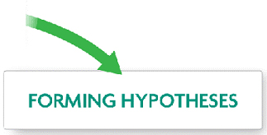***

***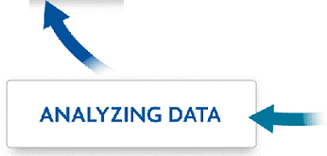 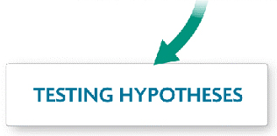***

Observation:

This means to collect data using one or more of the five senses. Data collected can either be **quantitative** or **qualitative**. Quantitative data is data represented via numbers. For example, the gorilla weighed 160kg or the room had 25 students in it. Qualitative data is data that is represented with some type of description. For example, the color of the shark was grey with white around the nose and belly or the female gorillas were notable smaller than the male gorillas.The most important aspect of observation is the fact that it CANNOT be biased. This means when you are observing something, you must be fair and not show favoritism.

Forming Hypotheses:

Often referred to as an “educated guess.” This means it is a preliminary possible explanation to a possible set of phenomena. Hypotheses are used to help scientists answer questions about something. Hypotheses can be wrong.

Testing Hypotheses

When you test a hypothesis, you are conducting an **experiment.** Experiments utilize statistics to analyze and interpret data. They also help scientists answer questions by showing cause-and-effect relationships. “If x happens, then y happens.” Remember that science only deals in the natural world, so experiments have to be tested in the natural world or simulated events that occur in the natural world. An experiment also only tests one variable at a time. This means there is an **independent variable,** **dependent variable, control group,** and **constants.**

|  |  |  |  |
| --- | --- | --- | --- |
| **Independent Variable** | **Dependent Variable** | **Control Group** | **Constants** |
| This is the condition or event that is being studied. It is often referred to as the manipulated variable because the experimenter can change or manipulate this variable.  Found in the **experimental group.**  0016_bhspe-010103 | This is the condition of event that may change due to changes in the independent variable. This is what is observed and measured in an experiment.  0016_bhspe-010103 | This is a group that does not receive the independent variable. It is used as comparison of the independent variable. This group receives all the same constants as the experimental group. | Often referred to as **controlled variables**. These are conditions or events which the experimenter attempts to keep the same in both the experimental groups and control group. |

Analyzing Data

Once scientists have conducted an experiment, they have accumulated data. This data then needs to be analyzed. This is where statistics and other branches of mathematics are utilized. Scientists take the data collected and attempt to make sense of it all. They can make charts, tables, graphs, plots, models, etc. with the data in hopes of drawing a conclusion about their hypothesis.

Evaluating Data

Once the data has been analyzed, it can then be evaluated and conclusions can be drawn. This part of the scientific method is where the scientist can then begin to formulate a **theory**. A theory is not a fact, but well-supported with evidence and observation. The theory may change depending on the results of new experiments. It may or may not be accepted by the scientific community.

Once a scientist has completed an experiment and has analyzed the data fully, they may publish the results in an article. By publishing work, scientists are able to share their findings with the scientific community in order to others in their own work. Scientific journals, websites, textbooks, and magazines are often sources of such published work.

**Put the steps of the scientific method in order.**

\_\_\_\_\_\_\_\_\_\_\_\_\_ 🡪 \_\_\_\_\_\_\_\_\_\_\_\_\_ 🡪 \_\_\_\_\_\_\_\_\_\_\_\_\_ 🡪 \_\_\_\_\_\_\_\_\_\_\_\_\_ 🡪 \_\_\_\_\_\_\_\_\_\_\_\_\_

**Now let’s do some practice using this method.**

1. Read the following scenario:

*All plants need water, minerals, carbon dioxide, sunlight, and living space. If these needs are not met, plants cannot grow properly. A biologist thought that plants would not grow well if too many were planted in a limited area. To test this idea, the biologist set up an experiment. Three containers were filled with equal amounts of potting soil. One bean seed was planted in Container 1, five bean seeds in Container 2, and ten bean seeds in container 3. All three containers received the same amount of water every day. The biologist measured the heights of the growing plants every day, after germination, for 10 days. Then the average height of the plants in each container each day was calculated and recorded. The biologist then plotted the data on a graph.*

Here is the data the biologist collected. In the space below, you need to organize the data in some way.

Container 1:

20, 50, 58, 60, 75, 80, 85, 90, 110, 120 (all mm)

Container 2:

16, 30, 41, 50, 58, 70, 75, 80, 100, 108 (all mm)

Container 3:

10, 12, 20, 24, 30, 35, 42, 50, 58, 60 (all mm)

\*The data above is per container and was recorded daily for 10 days.

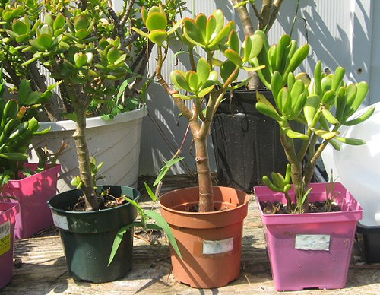

2. Based on the scenario above, write the hypothesis that you believe this biologist was testing.

\_\_\_\_\_\_\_\_\_\_\_\_\_\_\_\_\_\_\_\_\_\_\_\_\_\_\_\_\_\_\_\_\_\_\_\_\_\_\_\_\_\_\_\_\_\_\_\_\_\_\_\_\_\_\_\_\_\_\_\_\_\_\_\_\_\_\_\_\_\_\_\_\_\_\_\_\_\_\_\_

\_\_\_\_\_\_\_\_\_\_\_\_\_\_\_\_\_\_\_\_\_\_\_\_\_\_\_\_\_\_\_\_\_\_\_\_\_\_\_\_\_\_\_\_\_\_\_\_\_\_\_\_\_\_\_\_\_\_\_\_\_\_\_\_\_\_\_\_\_\_\_\_\_\_\_\_\_\_\_\_

\_\_\_\_\_\_\_\_\_\_\_\_\_\_\_\_\_\_\_\_\_\_\_\_\_\_\_\_\_\_\_\_\_\_\_\_\_\_\_\_\_\_\_\_\_\_\_\_\_\_\_\_\_\_\_\_\_\_\_\_\_\_\_\_\_\_\_\_\_\_\_\_\_\_\_\_\_\_\_\_

Why do you believe this was a good hypothesis to represent the biologist’s work? \_\_\_\_\_\_\_\_\_\_\_\_\_\_\_\_\_\_\_\_\_\_\_\_\_\_\_\_\_\_\_\_\_\_\_\_\_\_\_\_\_\_\_\_\_\_\_\_\_\_\_\_\_\_\_\_\_\_\_\_\_\_\_\_\_\_\_\_\_\_\_\_\_\_\_\_\_\_\_\_

\_\_\_\_\_\_\_\_\_\_\_\_\_\_\_\_\_\_\_\_\_\_\_\_\_\_\_\_\_\_\_\_\_\_\_\_\_\_\_\_\_\_\_\_\_\_\_\_\_\_\_\_\_\_\_\_\_\_\_\_\_\_\_\_\_\_\_\_\_\_\_\_\_\_\_\_\_\_\_\_

\_\_\_\_\_\_\_\_\_\_\_\_\_\_\_\_\_\_\_\_\_\_\_\_\_\_\_\_\_\_\_\_\_\_\_\_\_\_\_\_\_\_\_\_\_\_\_\_\_\_\_\_\_\_\_\_\_\_\_\_\_\_\_\_\_\_\_\_\_\_\_\_\_\_\_\_\_\_\_\_

3. Identify the following variables.

Independent Variable: \_\_\_\_\_\_\_\_\_\_\_\_\_\_\_\_\_\_\_\_\_\_\_\_\_\_\_\_\_\_\_\_\_\_\_\_\_\_\_\_\_\_\_\_\_\_\_\_\_\_\_\_\_\_\_\_\_

Why? \_\_\_\_\_\_\_\_\_\_\_\_\_\_\_\_\_\_\_\_\_\_\_\_\_\_\_\_\_\_\_\_\_\_\_\_\_\_\_\_\_\_\_\_\_\_\_\_\_\_\_\_\_\_\_\_\_\_\_\_\_\_\_\_\_

Dependent Variable: \_\_\_\_\_\_\_\_\_\_\_\_\_\_\_\_\_\_\_\_\_\_\_\_\_\_\_\_\_\_\_\_\_\_\_\_\_\_\_\_\_\_\_\_\_\_\_\_\_\_\_\_\_\_\_\_\_\_

Why? \_\_\_\_\_\_\_\_\_\_\_\_\_\_\_\_\_\_\_\_\_\_\_\_\_\_\_\_\_\_\_\_\_\_\_\_\_\_\_\_\_\_\_\_\_\_\_\_\_\_\_\_\_\_\_\_\_\_\_\_\_\_\_\_\_

Control Group: \_\_\_\_\_\_\_\_\_\_\_\_\_\_\_\_\_\_\_\_\_\_\_\_\_\_\_\_\_\_\_\_\_\_\_\_\_\_\_\_\_\_\_\_\_\_\_\_\_\_\_\_\_\_\_\_\_\_\_\_\_\_\_

Why? \_\_\_\_\_\_\_\_\_\_\_\_\_\_\_\_\_\_\_\_\_\_\_\_\_\_\_\_\_\_\_\_\_\_\_\_\_\_\_\_\_\_\_\_\_\_\_\_\_\_\_\_\_\_\_\_\_\_\_\_\_\_\_\_\_

Constants: \_\_\_\_\_\_\_\_\_\_\_\_\_\_\_\_\_\_\_\_\_\_\_\_\_\_\_\_\_\_\_\_\_\_\_\_\_\_\_\_\_\_\_\_\_\_\_\_\_\_\_\_\_\_\_\_\_\_\_\_\_\_\_\_\_\_

Why? \_\_\_\_\_\_\_\_\_\_\_\_\_\_\_\_\_\_\_\_\_\_\_\_\_\_\_\_\_\_\_\_\_\_\_\_\_\_\_\_\_\_\_\_\_\_\_\_\_\_\_\_\_\_\_\_\_\_\_\_\_\_\_\_\_

4. When we analyze data, we organize it in some type of way that makes it easy for others to interpret. One such way is forming a graph. Using the data collected by the biologist, make a graph. Be sure to use the appropriate type of graph and follow the checklist provided on the next page.

.

Now, look back over your graph and see how you did. Fill out the checklist.

**Graph Checklist:**

* Clear title that tells the reader exactly what is shown with units
* X-axis labeled properly with IV
* X-axis has proper unit
* Y-axis labeled properly with DV
* Y-axis has proper unit
* Scale is consistent
* Key is provided (if needed)
* Data is clear and legible

5. When a scientist evaluates the results of his or her experiment, he or she is *drawing conclusions*. When writing a conclusion, there are some things that should always be included. You should **always restate what your hypothesis was and why you had the questions you did**. You should **include the results of the experiment**. This means including both quantitative and qualitative data collected. You should talk about the experiment and what may have gone wrong and why. For example, if in the scenario above, the biologist forgot to water the plants one day, he would need to record that in the conclusions. Something like forgetting to water the plants could have affected the heights of the plant. You must be honest in your conclusions and include everything pertinent to the experiment.

Conclusions are guides for future experiments. They allow other scientists, including the scientist behind the original experiment, to further the investigation to see if the same results would be gained once again. The more support for an idea there is, the closer it is to becoming widely accepted by the scientific community. In the space below, I want you to write a conclusion that would go along with the scenario mentioned earlier. If you were this biologist and had conducted this experiment, you would need to write a conclusion about it.

\_\_\_\_\_\_\_\_\_\_\_\_\_\_\_\_\_\_\_\_\_\_\_\_\_\_\_\_\_\_\_\_\_\_\_\_\_\_\_\_\_\_\_\_\_\_\_\_\_\_\_\_\_\_\_\_\_\_\_\_\_\_\_\_\_\_\_\_\_\_\_\_\_\_\_\_\_\_\_\_\_\_\_\_\_\_\_\_\_\_\_\_\_\_\_\_\_\_\_\_\_\_\_\_\_\_\_\_\_\_\_\_\_\_\_\_\_\_\_\_\_\_\_\_\_\_\_\_\_\_\_\_\_\_\_\_\_\_\_\_\_\_\_\_\_\_\_\_\_\_\_\_\_\_\_\_\_\_\_\_\_\_\_\_\_\_\_\_\_\_\_\_\_\_\_\_\_\_\_\_\_\_\_\_\_\_\_\_\_\_\_\_\_\_\_\_\_\_\_\_\_\_\_\_\_\_\_\_\_\_\_\_\_\_\_\_\_\_\_\_\_\_\_\_\_\_\_\_\_\_\_\_\_\_\_\_\_\_\_\_\_\_\_\_\_\_\_\_\_\_\_\_\_\_\_\_\_\_\_\_\_\_\_\_\_\_\_\_\_\_\_\_\_\_\_\_\_\_\_\_\_\_\_\_\_\_\_\_\_\_\_\_\_\_\_\_\_\_\_\_\_\_\_\_\_\_\_\_\_\_\_\_\_\_\_\_\_\_\_\_\_\_\_\_\_\_\_\_\_\_\_\_\_\_\_\_\_\_\_\_\_\_\_\_\_\_\_\_\_\_\_\_\_\_\_\_\_\_\_\_\_\_\_\_\_\_\_\_\_\_\_\_\_\_\_\_\_\_\_\_\_\_\_\_\_\_\_\_\_\_\_\_\_\_\_\_\_\_\_\_

\_\_\_\_\_\_\_\_\_\_\_\_\_\_\_\_\_\_\_\_\_\_\_\_\_\_\_\_\_\_\_\_\_\_\_\_\_\_\_\_\_\_\_\_\_\_\_\_\_\_\_\_\_\_\_\_\_\_\_\_\_\_\_\_\_\_\_\_\_\_\_\_\_\_\_\_\_\_\_\_\_\_\_\_\_\_\_\_\_\_\_\_\_\_\_\_\_\_\_\_\_\_\_\_\_\_\_\_\_\_\_\_\_\_\_\_\_\_\_\_\_\_\_\_\_\_\_\_\_\_\_\_\_\_\_\_\_\_\_\_\_\_\_\_\_\_\_\_\_\_\_\_\_\_\_\_\_\_\_\_\_\_\_\_\_\_\_\_\_\_\_\_\_\_\_\_\_\_\_\_\_\_\_\_\_\_\_\_\_\_\_\_\_\_\_\_\_\_\_\_\_\_\_\_\_\_\_\_\_\_\_\_\_\_\_\_\_\_\_\_\_\_\_\_\_\_\_\_\_\_\_\_\_\_\_\_\_\_\_\_\_\_\_\_\_\_\_\_\_\_\_\_\_\_\_\_\_\_\_\_\_\_\_\_\_\_\_\_\_\_\_\_\_\_\_\_\_\_\_\_\_\_\_\_\_\_\_\_\_\_\_\_\_\_\_\_\_\_\_\_\_\_\_\_\_\_\_\_\_\_\_\_\_\_\_\_\_\_\_\_\_\_\_\_\_\_\_\_\_\_\_\_\_\_\_\_\_\_\_\_\_\_\_\_\_\_\_\_\_\_\_\_\_\_\_\_\_\_\_\_\_\_\_\_\_\_\_\_\_\_\_\_\_\_\_\_\_\_\_\_\_\_\_\_\_\_\_\_\_\_\_\_\_\_\_\_\_\_\_\_

\_\_\_\_\_\_\_\_\_\_\_\_\_\_\_\_\_\_\_\_\_\_\_\_\_\_\_\_\_\_\_\_\_\_\_\_\_\_\_\_\_\_\_\_\_\_\_\_\_\_\_\_\_\_\_\_\_\_\_\_\_\_\_\_\_\_\_\_\_\_\_\_\_\_\_\_\_\_\_\_\_\_\_\_\_\_\_\_\_\_\_\_\_\_\_\_\_\_\_\_\_\_\_\_\_\_\_\_\_\_\_\_\_\_\_\_\_\_\_\_\_\_\_\_\_\_\_\_\_\_\_\_\_\_\_\_\_\_\_\_\_\_\_\_\_\_\_\_\_\_\_\_\_\_\_\_\_\_\_\_

**Scientific Inquiry**

**Standard B – 1: The student will demonstrate an understanding of how scientific inquiry and**

**technological design, including mathematical analysis, can be used**

**appropriately to pose questions, seek answers, and develop solutions.**

*Indicator B – 1:5: Organize and interpret the data from a controlled scientific investigation by*

*using mathematics (including formulas and dimensional analysis), graphs,*

*models, and/or technology.*

**Objectives:**

***Organize*** data from a controlled scientific investigation.

***Interpret*** data from a controlled scientific investigation.

**Vocabulary Words:**

There are no Vocabulary words for this topic.

\*\*\*\*\*\*\*\*\*\*\*\*\*\*\*\*\*\*\*\*\*\*\*\*\*\*\*\*\*\*\*\*\*\*\*\*\*\*\*\*\*\*\*\*\*\*\*\*\*\*\*\*\*\*\*\*\*\*\*\*\*\*\*\*\*\*\*\*\*\*\*\*\*\*\*\*\*\*\*\*\*\*\*\*\*\*\*\*\*\*\*\*\*\*\*\*\*\*\*\*\*\*\*\*\*\*\*\*\*\*\*\*\*\*\*

**Graphing in Scientific Investigations**

In science, it is important that data collected from scientific investigations be neat, legible, and easily interpreted. In order for this to be the case, scientists rely heavily on charts, graphs, and formulas.

**Charts**

Data should be organized in charts which lists the values for the independent variable in the first column & list the values fro the dependent variable in a column to the right of the impendent variable.

Example of a chart:

|  |  |
| --- | --- |
| Length (cm) | Mass (g) |
| 14 | 27 |
| 8 | 15 |
| 12 | 23 |
| 11 | 22 |
| 9 | 18 |

Use the following information to construct a chart in the space below.

During a scientific investigation, students had to measure 5 objects. The first object was 8cm long and weighed 15g. The second object was 9cm long and weighed 18g. The third object was 11cm long and weighed 23g. The fourth object was 12cm long and weighed 23g. The fifth and last object measured was 14cm long and weighed 27g.

**Graphs**

Once charts are made during a scientific investigation, graphs are then constructed to help interpret the relationship between the independent variable and the dependent variable.

* ***“DRY MIX”*** will help you remember the dependent (responding) variable goes on the Y-axis and the independent (manipulated) variable goes on the X-axis.
* There are many types of graphs:
  + Line
  + Bar
  + Circle

For each of the following, indicate which type of graph it is.

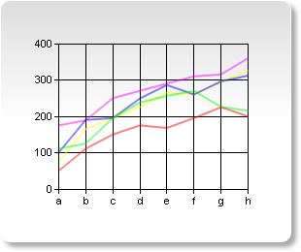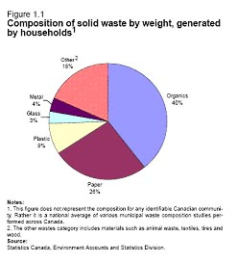

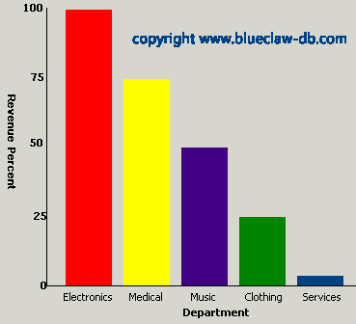

\_\_\_\_\_\_\_\_\_\_\_\_\_\_\_\_\_ \_\_\_\_\_\_\_\_\_\_\_\_\_\_\_\_\_\_ \_\_\_\_\_\_\_\_\_\_\_\_\_\_\_\_\_\_\_

For each of the following descriptions, indicate which type of graph would be constructed.

1. Used for non-continuous data which is usually categorical. \_\_\_\_\_\_\_\_\_\_\_\_\_\_\_\_\_
2. Used to show a trend over time. \_\_\_\_\_\_\_\_\_\_\_\_\_\_\_\_
3. Shows the relationship among the parts of a whole. \_\_\_\_\_\_\_\_\_\_\_\_\_\_\_\_\_
4. Often involves percentage data. \_\_\_\_\_\_\_\_\_\_\_\_\_\_\_\_\_\_\_\_
5. Used for continuous quantitative data. \_\_\_\_\_\_\_\_\_\_\_\_\_\_\_\_\_\_\_\_\_\_\_

Graphs can either show a ***direct variation* or an *inverse variation*.**

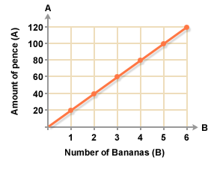

A direct variation (or proportion) is one in which, one variable increases as the other increases or as one variable decreases the other decreases. A straight line with a positive slope indicates a direct relationship that changes at a constant rate.

An inverse variation (or proportion) is one in which the product of two quantities is a constant. As one quantity increases, the other decreases.

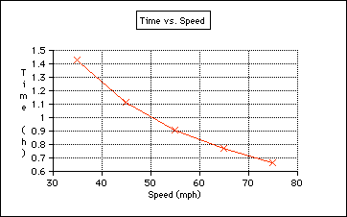

**Models**

Information gathered during a scientific investigation is not always used to only construct a graph. Models are also constructed. A model is an idealized representation of an object or process that is used to better understand or explain how it functions.

Common Models: descriptions, analogies, diagrams, 3-D models.

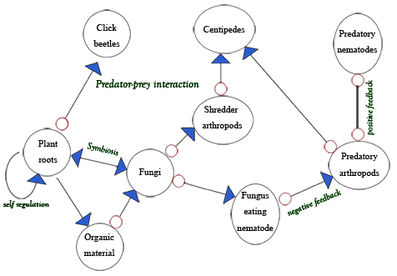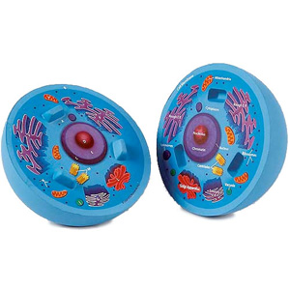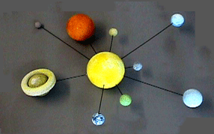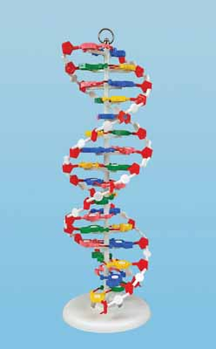Models can be used to represent some of the important properties of an actual object or system. They can help scientists test hypotheses, evaluate data, and make predictions.

**Technology**

Technology is the application of scientific knowledge to develop new products, procedures, or solutions for real-world problems.

Technology is all about science. Were it not for science, there would not be advancements in the field of technology.

**Think of 5 pieces of technology that have made human life “better”.**

**Scientific Inquiry**

**Standard B – 1: The student will demonstrate an understanding of how scientific inquiry and**

**technological design, including mathematical analysis, can be used**

**appropriately to pose questions, seek answers, and develop solutions.**

*Indicator B – 1:7: Evaluate a technological design or product on the basis of designated*

*criteria (including cost, time, and materials).*

*Indicator B – 1:8: Compare the processes of scientific investigations and technological*

*design.*

**Objectives:**

***Evaluate*** a technological design or product on the basis of designated criteria.

***Compare*** the technological design process and scientific investigation.

**Vocabulary Words:**

There are no Vocabulary words for this topic.

\*\*\*\*\*\*\*\*\*\*\*\*\*\*\*\*\*\*\*\*\*\*\*\*\*\*\*\*\*\*\*\*\*\*\*\*\*\*\*\*\*\*\*\*\*\*\*\*\*\*\*\*\*\*\*\*\*\*\*\*\*\*\*\*\*\*\*\*\*\*\*\*\*\*\*\*\*\*\*\*\*\*\*\*\*\*\*\*\*\*\*\*\*\*\*\*\*\*\*\*\*\*\*\*\*\*\*\*\*\*\*\*\*\*\*

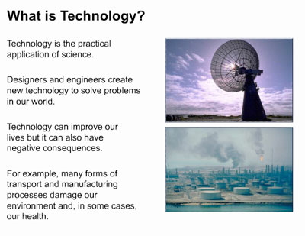

**Technological Design Process**

Technological design is an important

part of engineering, the field that applies scientific knowledge to practical problems. There are 4 main steps in the technological design process.

The four main steps of the technological design process are:





The first step in the technological design process is to identify the problem. Often, engineers or inventors try to solve problems in their own \_\_\_\_\_\_\_\_\_\_\_

or \_\_\_\_\_\_\_\_\_\_\_\_\_\_\_\_.



Once the problem has been identified, a \_\_\_\_\_\_\_\_\_\_ has to be proposed. In order to do this, \_\_\_\_\_\_\_\_\_\_\_ or \_\_\_\_\_\_\_\_\_\_\_\_ may be created. Also, any \_\_\_\_\_\_\_\_\_\_\_\_\_ and \_\_\_\_\_\_\_\_\_\_\_\_\_ have to be identified and the \_\_\_\_\_\_\_\_\_\_\_ has to be identified. A list of potential \_\_\_\_\_\_\_\_\_\_ and \_\_\_\_\_\_\_\_\_\_ also is made.



Once a design plan has been studied and accepted, a design team must carry out the plan. This stage of development is known as \_\_\_\_\_\_\_\_\_\_\_\_\_\_\_\_\_\_. This is a step-by-step strategy to solve the problem.



A completed design

must be \_\_\_\_\_\_\_\_\_\_\_ to

decide if it meets the

original goals.

The results of technological design often improve people’s lives. Each new development offers both \_\_\_\_\_\_\_ and \_\_\_\_\_\_\_. Benefits are how the technology meets people’s needs. The risks include ways the technology might harm humans or the environment. This is called \_\_\_\_\_\_\_\_\_\_\_-\_\_\_\_\_\_\_\_\_ analysis.

For each of the following descriptions, decide whether it describes a *scientific investigation (SI), technological design (TD), or both.* Refer to your previous notes to help you. Remember, a scientific investigation answers a question whereas the technological design process produces a product based on a need.

1. Identifies a problem-asks a question
2. Communicates the product or process
3. Analyzes the results
4. Designs an investigation or experiment
5. Identifies a problem or need
6. Evaluates the process or product-did it meet the criteria?
7. Communicates the findings
8. Researches related information
9. Designs a product or process
10. Conducts an experiment-repeated trials
11. Evaluates the conclusion-did the results refute or verify the hypothesis
12. Implements the design or the process-repeated testing