**Unit 2 Part 1 Study Guide**

**Biology**

1. List 3 things all cells have. 2. List the 3 components of The Cell Theory

A. ________________________________ A. _________________________________________________

B. ________________________________ B. _________________________________________________

C. ________________________________ C. _________________________________________________

3. Label the following cell.

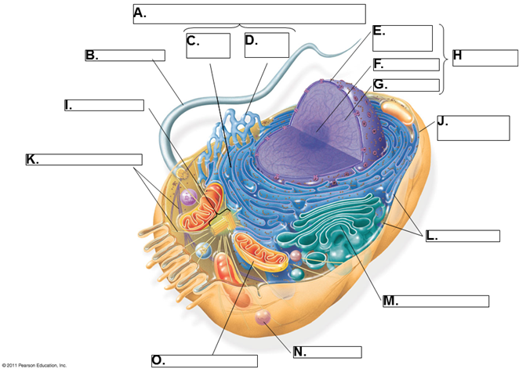

4. Decide whether the following are a prokaryote or a eukaryote.

A. Plant: ____________________________ B. Bacterium: _____________________________

C. Tree: _____________________________ D. E. coli: ___________________________________

E. Blood Cell: _______________________ F. Pig Skin Cell: _____________________________

G. Cheek Cell: _______________________ H. Salmonella: ______________________________

5. What is the main difference between a prokaryote and eukaryote?

6. Only eukaryotic cells have a ___________________ bound nucleus and _________________ bound organelles.

7. _________________________________ is a structure that regulates what enters and leave the cell, is very

fluid, encloses the contents of a cell, and is selectively permeable.

8. _______________________ is a structure that performs a particular function in a cell.

9. Can a prokaryote have a cell wall? ________________

10. _________________________ are tiny hair-like structures that can line the outside of a cell.

11. ___________________ is filled with enzymes that break down old organelles or parts of a cell.

12. What types of cells will have flagella? (plant? animal? bacteria?)

13. The Nuclear ____________________ is a double membrane that surrounds the nucleus. It has

_________________ through it that allow for ________________ and RNA to leave.

14. If the cell was a city, what would the power house be? _____________________________

a. What type of cell in the human body would have a lot of these? _________________________

15. What is the organelle found in plants only which is the site of photosynthesis? _____________________

16. In plants, the _________________ is responsible for holding water. When the _________________ is full, the

plant is happy, and when the ________________ is empty, the plant looks sad (droops).

17. The cell’s chromosomes are found in the ___________________.

18. ________________________ is the major structural sugar found in the cell wall of plants.

19. ________________ 🡪 tissue 🡪 ________________ 🡪 organ system

20. __________________ transport requires no energy from the cell and always flows from high to low.

21. Putting food color in a beaker of water demonstrates what process of passive transport? ___________

22. If you have swollen gums, why would it help to rinse with salt water?

23. Once a solution has reached equilibrium, do the molecules quit moving or continue to move?

24. Does diffusion only happen across a membrane?

25. Match the following. Some may have more than one match.

A. Diffusion D. Endocytosis

B. Osmosis E. Exocytosis

C. Facilitated Diffusion F. Sodium-Potassium Pump

1. Passive Transport 6. Water through a semi-permeable membrane

2. Active Transport 7. Requires energy from ATP

3. Low 🡪 High 8. Potassium ions

4. CO2 and O2 9. Uses vesicles (sacs)

5. Uses no ATP