Vocab for Chapter 16 and 15 (we will be learning 16 first): Physical Science
Please number your paper according to the questions.

Compare and Contrast the following terms
- elements / compounds
- substance / mixture
- heterogeneous mixture / homogeneous mixture
- physical change / chemical change
- heat of Vaporization/ heat of fusion
- Amorphous solids / Crystalline Solids (liquid crystals)

- Using the chart, define, describe movement, and draw the molecules in each state.
Type | Define | Movement | Molecular drawing
Solid

Liquid

Gas

Plasma

- In what ways does water act differently than other liquids? List 3 real life situations, where knowing how water freezes is valuable.
- Define viscosity. Put syrup, water, and olive oil in order of most viscous to least viscous.
- Give a real life example of each pressure law (Boyles and Charles)
- Please give 4 real life examples of how Thermal expansion can affect our daily lives.
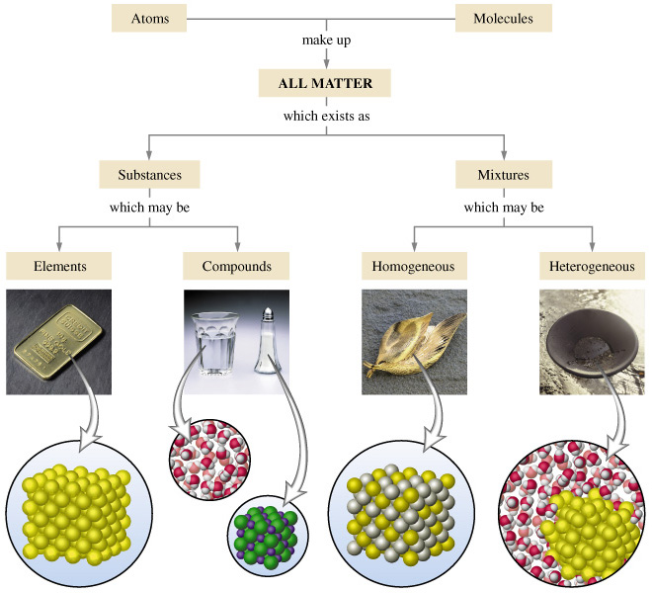

Vocab for Chapter 16 and 15 (we will be learning 16 first): Physical Science
Please number your paper according to the questions.

Compare and Contrast the following terms
- elements / compounds
- substance / mixture
- heterogeneous mixture / homogeneous mixture
- physical change / chemical change
- heat of Vaporization/ heat of fusion
- Amorphous solids / Crystalline Solids (liquid crystals)

- Using the chart, define, describe movement, and draw the molecules in each state.
Type | Define | Movement | Molecular drawing
Solid

Liquid

Gas

Plasma

- In what ways does water act differently than other liquids? List 3 real life situations, where knowing how water freezes is valuable.
- Define viscosity. Put syrup, water, and olive oil in order of most viscous to least viscous.
- Give a real life example of each pressure law (Boyles and Charles)
- Please give 4 real life examples of how Thermal expansion can affect our daily lives.

