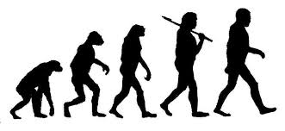
What are your thoughts?

1. When you see this image, what do you think of?

2. The Acacia Ant and an Acacia tree are very unique. These 2 species are dominantly located in Savannahs (Lion King). Look up the relationship between these 2 organisms. What is so unique about it? How would you explain their specialized relationship? Does this have ANYTHING to do with evolution?

3. I know that when I look at the mountains, and when I think about how incredible our bodies work, I often wonder about how all of us came to be. There is such a balance on Earth, between animals, plants, and the earth we walk on. Truly amazing!! Can you think of one specific organism, relationship between living and non-living, or landform that has you baffled? (Think about watching educational stuff on TV) What is it? What is so amazing about it? How did it become what it is?

4. Research the human appendix. What does it do for us? Do we need it? What can happen if it becomes infected? Why do you think our DNA tells our body to make this accessory organ? How does this relate to evolution?

5. http://www.pbs.org/wgbh/evolution/change/grand/index.html
Read the article. Write one paragraph telling me about your thoughts on this article.

